****GOVERNMENT COLLEGE OF ENGINEERING, KEONJHAR

**AT: - JAMUNALIA, OLD TOWN PO: - KEONJHAR**

**ODISHA, 758001**

**Lecture Note on**

MINERAL PROCESSING TECHNOLOGY FOR 4TH SEMESTER MINING ENGINEERING

By: -

**Umakanta Behera**

**Assistant Professor**

**Department of Mining Engineering**

**Government College of Engineering, Keonjhar**

**CONTENTS**

|  |  |  |
| --- | --- | --- |
| **SL.NO.** | **TOPIC** | **PAGE NO.** |
| 1. | CRUSHING OF COAL - AN OUTLINE | 3-27 |
| 2. | GRINDING MILL | 27-31 |
| 3. | SAG AND AG( SEMI-AUTOGENOUS AND AUTOGENOUS GRINDING) | 32-34 |
| 4. | SCREENING OF COAL - AN OUTLINE | 35-54 |
| 5. | CLASSIFICATION | 55-55 |
| 6. | BENEFICIATION USING HYDRO CYCLONES | 56-59 |
| 7. | TERMINAL VELOCITY (SETTLING VELOCITY) | 60-61 |
| 8. | GRAVITY SEPARATION OPERATION | 61-64 |
| 9. | HEAVY MEDIA SEPARATION OR DENSE MEDIA SEPARATION : ( HMS)OR (DMS) | 64-64 |
| 10. | FROTH FLOTATION – FUNDAMENTAL PRINCIPLES | 65-68 |
| 11. | MAGNETIC SEPARATION | 69-71 |
| 12. | SEPARATION OF MINERALS BY ELECTRIC SEPARATION | 71-72 |
| 13. | FLOW SHEET OF BENEFICIATION CHROMITE ORE | 73-74 |
| 14. | IRON ORE BENEFICIATION | 74-75 |
| 15. | BENEFICATION OF LEAD & ZINC ORES | 76-76 |
| 16. | ENVIRONMENTAL ISSUE DUE TO BENEFICIATION | 76-77 |
| 17. | TAILINGS DISPOSAL | 77-78 |
| 18. | THICKENERS — TYPES, WORKING PRINCIPLE & APPLICATIONS | 78-80 |

CRUSHING OF COAL - AN OUTLINE

INTRODUCTION

Primary objectives of coal crushing and screening, also known as size reduction and size separation, respectively are to reduce the run-of-mine coal to a size suitable for subsequent requirement, e.g., washing or transportation or general market or specific client specification. Crushing and screening are together commonly referred to as size preparation. Irrespective of coal qualities coal crushing is guided by certain general principles. Notables among those are as follows:

1. A particular type of crusher is most efficient in acting on a certain size range of feed.
2. Crushing is performed most efficiently in a series of stages; no one machine efficiently reduces large sizes to small sizes by repeated breakage.
3. For rapid and efficient size reduction, finer material should be scalped as quickly as possible from the crusher feed.
4. A crusher design should be chosen to handle the hardest material in the coal, but should not be of heavier (more costly) construction than needed.
5. Any crusher can be used at any stage, provided that is the most cost effective choice.

There is a rough distinction between breaking and crushing. Breaking as a term is usually applied to size reduction operations on large materials where coal is broken along natural cleavage lines. Crushing generally refers to size reduction of material below 300/ 500mm. The term “grinding” covers the size reduction of material of about 25 mm in size to micron sizes, as in the production of pulverized fuel for use in a power plant.

Before we move further, some of the terminology used in coal crushing needs clarification.

* Top size: the largest allowable particle size in a feed or product (d100)
* Nominal size: at least 90% of the material passes through this size (d90)
* Oversize: material too large to pass through a specific screen aperture or grizzly opening; alternately material larger than the crusher discharge setting (set) size
* Closed Side Setting: This is the minimum gap between the two opposing crushing faces of a reciprocating crusher, e.g. bowl and mantle liners on a cone crusher when the eccentric is at its closest limit. This term is used when setting the size at which the crusher will crush. Normally a crusher with new liners will pass 80% below this size (d80) and 20% above
* Open Side Setting: This is the maximum gap between the two opposing crushing faces of a reciprocating crusher
* Choked Feed: operating the crusher with a completely filled crusher chamber
* Closed Circuit Crushing: a system in which oversize material is screened from the crusher product and returned for another pass through the crusher; usually carried out at the final stage of crushing
* Circulating Load: The amount of oversize returned to the crusher after screening the crusher product, usually expressed either in tph or in % of the crusher feed
* Friable: material that breaks easily
* Reduction Ratio: usually the ratio of the top size of feed material to the top size of crusher discharge (RR = d100F/ d100P), but could be expressed in terms of any other characteristic size, e.g. d80; a ratio of less than 4:1 or 3:1 is desirable in coal crushing to avoid excessive fines generation
* Scalping: removing all sizes smaller than product top size from the crusher feed
* Tramp Material: Bolts, shovel teeth, picks, iron pieces, timber supports and other foreign material that may be present in a crusher feed

ROM coal obtained from the mines generally shows a top-size of 300-2000 mm. Top-size is smaller for coal obtained from underground pits, whereas comparatively larger for coal obtained from surface mines. Following factors affect the top-size and size distribution of ROM coal.

* Underground or surface mining
* Mechanised, semi-mechanised or manual mining
* Method and intensity of blasting
* Presence or absence of in-pit crushing
* Material handling system used to transport the coal from mine to plant

Subsequent to mining, ROM coal is subjected to crushing in stages. The types, sizes and number of crushers employed in a complete size reduction system would vary with such factors as the volume or tonnage of coal to be crushed, top-size and size distribution of ROM coal, the hardness of coal and the size and dimension required for the final product. Rotary breakers, recently sizers and single roll crushers are commonly used as primary crushers, whereas double roll and impact group of crushers are usually applied in secondary and tertiary crushing. Reciprocating crushers, such as jaw, gyratory and cone crushers are also sometimes used to crush hard to very hard coal in large capacity operations, e.g. in coal handling plants of large capacity mines.

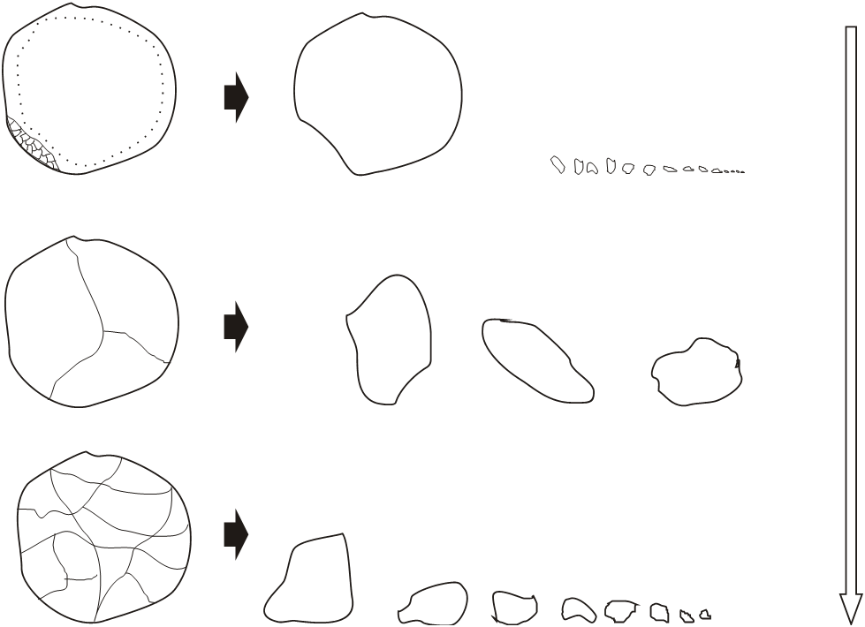

a

b

c

Increasing energy intensity

Abrasion

(Localised Stressing)

Shatter (Impact)

Cleavage (Compression)

Figure 1 Typical Mechanisms of Fracture

When coal is crushed for the purpose of washing, it is important to remember that based on US practices, relationship of coal washing costs, coarse to fines, generally is given as 1:3 or 1:4, whereas in India it is estimated to be around 1:5 – 1.6. Therefore, as and when washing is required, as far as liberation permits, generation of fines in coal crushing should be bare minimum. Otherwise also fines pose a major problem in handling, transportation and utilization of coal. Therefore, a major restriction imposed on coal crushing is minimum generation of fines.

Fundamentals of Breakage

There are four basic actions by which coal is reduced in size. These are Compression, Shear, Impact and Attrition. Most crushers employ a combination of these crushing “methods”. For a particle to fracture, a stress high enough to exceed the fracture strength of the particle is required.



Abrasion

(Coarse product)

Cleavage

Shatter

Abrasion (Fine Product)

Figure 2 Fracture Product Size Distributions

The manner in which the particle fractures depends on the nature of the particle, and on the manner, in which the force on the particle is applied. This force could be applied at either a fast or a slow rate, and the rate affects the nature of fracture. Some commonly used terms to describe the various mechanisms of single particle fracture are *abrasion*, *cleavage* and *shatter*.

Abrasion fracture occurs when insufficient energy is applied (usually inadvertently) to cause significant fracture of the particle. Rather, localized stressing occurs and a small area is fractured to give a distribution of very fine particles and one large daughter particle (Fig. 1 &2). Abrasion may occur in any crusher set at any size, but is generally found in reciprocating and in roll crushers. Cleavage mechanism of fracture is a direct outcome of compression (Fig. 1) and occurs when the energy applied is just sufficient to load comparatively few regions of the particle to the fracture point, and only a few particles result. Their size is comparatively closer to the mother particle size. Typically this situation occurs under conditions of slow compression, where the fracture immediately relieves the loading on the particle. Fracture by shatter occurs when the applied energy is well in excess of that required for fracture; under these conditions many areas in the particle are overloaded and the result is a comparatively large number of daughter particles with a wide spectrum of sizes (Fig. 1 &2). This occurs under conditions of rapid loading such as in a high velocity impact.

*Compression*

As the name implies crushing by compression is done between two surfaces (Fig. 3a), with the work being done by one or both crushing surfaces. Jaw and other reciprocating crushers using compression are suitable for reducing extremely hard and abrasive rock. However, some jaw crushers employ attrition as well as compression and are not as suitable for abrasive rock since the rubbing action accentuates the wear on the crushing surfaces. Compression should be used in the following circumstances:

* For hard and tough materials
* For abrasive materials
* For non-sticky materials (low moisture content and minimal amount of clays)
* When a uniform product with minimal fines is desired
* When the finished product is relatively coarse (>40mm)
* When materials will break cubically

*Impact*

In crushing terminology, impact refers to the sharp, instantaneous impingement of one moving object against another (Fig. 3b). Both objects may be moving, e.g. falling rock hit by a moving

1. compressi**on**

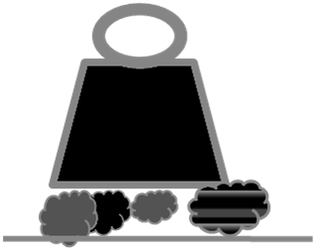

Primary effect for harder materials in ReciprocatingCrushers

Sharp instantaneous impingement

b) impact

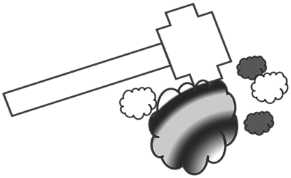

Secondary effect in Toothed Roll Crushers

c) shear

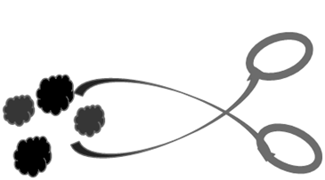

Secondary effect in Breakers & Double Roll Crushers

d) attrition

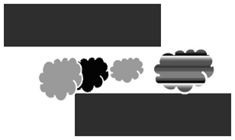

Fig. 3 Four Common Modes of Crushing

Hammer or one object may be motionless, such as a rock being struck by hammer blows. There are two variations of impact: gravity (free fall) impact and dynamic impact. Coal dropped into a hard surface, such as steel plate, is an example of gravity impact. Gravity impact is most often used when it is necessary to separate two materials with relatively different friability. The more friable material is broken, while the less friable material remains unbroken. Separation can then be done by screening. Material dropped in front of a moving hammer (both objects in motion) illustrates dynamic impact. When crushed by gravity impact, the stationary object momentarily stops the free-falling material, but when crushed by dynamic impact, the material is unsupported and the force of impact accelerates movement of the reduced particles toward breaker blocks and/or other hammers.

*Shear*

Shear consists of a trimming (Fig. 3c) or cleaving action (Fig. 1) rather than the rubbing action associated with attrition. Shear is usually combined with other methods of crushing. A toothed single or double roll crusher combines shear with impact and compression, producing shatter and cleavage mechanisms of fracture. Shear crushing is normally required under the following conditions:

* When material is friable
* For primary crushing with a reduction ratio of 1:6
* When a minimum amount of fines is desired
* When a coarse product is required (usually no finer than 40mm)

*Attrition*

Attrition is a term applied to the reduction of materials by scrubbing them between two hard surfaces (Fig. 3d). Hammer mills and horizontal impactors operate with close clearance between the hammers and the screen bars and/or liners. They reduce by attrition combined with shear and impact. Though attrition consumes more power and exacts heavier wear on hammers, liners and screen bars, it is practical for crushing the less abrasive materials such as coal. This type of crushing can however generate a high percentage of fines. Attrition crushing is commonly used in the following circumstances:

* When materials are friable and not too abrasive
* When a closed circuit is not desirable to control top size
* When a maximum of fines is required

In practice of course, abrasion, cleavage and shatter mechanisms of fracture do not occur in isolation, even in course of breakage of a single particle. Particularly significant is the situation, commonly occurring in crushers, where attrition occurs at the loading points (Fig. 4). Fracture due to a high velocity impact in which there is insufficient energy to result in shatter can yet cause attrition of the particle surface; the resultant fracture is essentially abrasion. If very small fractions of a particle are broken off because of a shear force applied at the surface, the cumulative effect is abrasion. Strictly speaking, of course, this is not a single fracture event.

Coal crushing usually calls for minimum generation of fines. Although some crushers will produce fewer fines (say -3mm) than others, the ideal crusher that produces no fines has not yet been designed. Generally speaking, the greater the degree of size reduction in a single operation the more fines are produced. It is better if minimum fines production is required, to reduce the coal to a size larger than that required, screen out the material of the desired size and further crush the oversize. This “stage crushing” is the best way of producing a minimum amount of fines with a given set of equipment. Furthermore, it is always good practice to remove through scalping any naturally occurring undersize in the crusher feed prior to crushing, thereby reducing unnecessary wear to the crusher components, reducing fines generation and also reducing the crusher capacity requirement and therefore reducing both capital and operating cost.

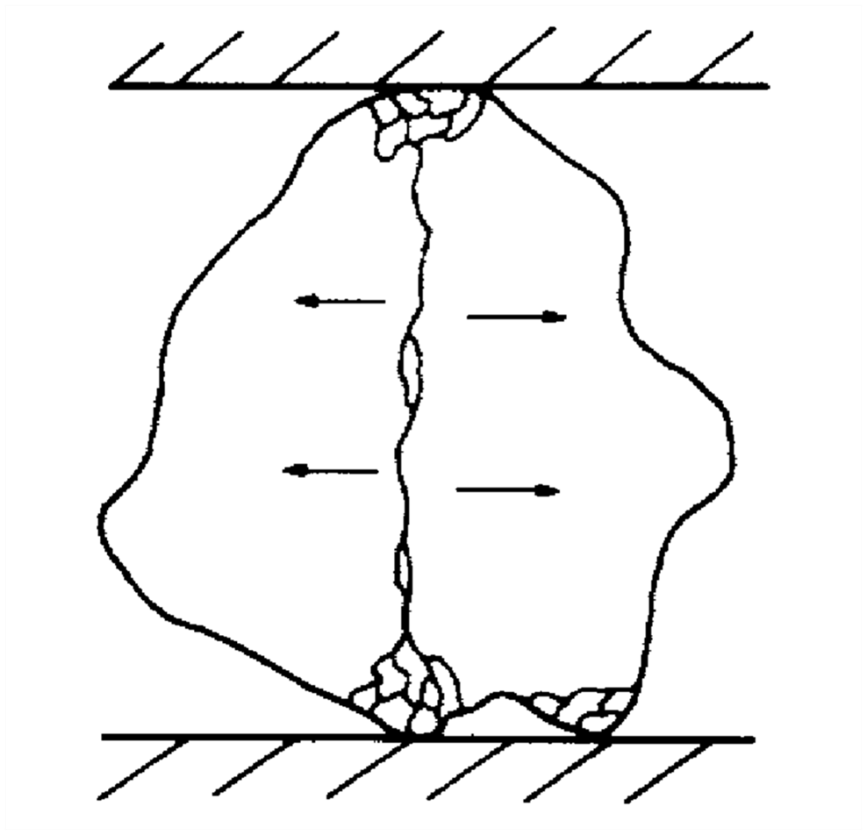

Figure 4 Combinations of Fracture Mechanisms as Occurs in Practice

*Grindability*

HGI indicates the relative ease with which a coal could be crushed with reference to a standard coal. Traditionally reference coal has a HGI of 100; the larger the value, the softer the coal. HGI determination in triplicate (50gm x 3) is essential in selection of crushers and pulverisers for coal applications. Initial coal sample is –1.16+0.6mm, in size.

HGI = 13 +6.93W (1)

Where W is the weight of the material passing through 200mesh or 0.075mm. Apart from crusher selection, HGI (Table 1) is also used in selecting the material for construction of actual crushing faces, such as roll crusher teeth, hammer tips, jaw crusher plates, cone crusher liners and in designing the material handling system, e.g. number of transfer points and their heights, belt speed, selection of liner materials used in chutes, bins, bunkers, etc. HGI is also used in pulveriser capacity calculation.

Table 1 A Generalised Classification of Coal Based on HGI

|  |  |  |  |  |  |  |
| --- | --- | --- | --- | --- | --- | --- |
| HGI | 30-50 | 50-70 | >70 | 70-100 | 100-120 | >120 |
| US Nomenclature | Hard | Medium Soft | Soft |  |  |  |
| CMPDI Nomenclature | Hard | Moderately Hard |  | Soft | Very Soft | Very Very Soft |

SE = f x HGI X RR (d50) (2)

Where f is a characteristic constant and RR (d50) is the reduction ratio targeted or achieved based on 50% passing size and SE is the energy per unit of throughput required to reduce the feed to required product size.

Therefore, (E/ TPH) = f x HGI X RR (d50) (3)

Or, (E/ ρ. QV) = f x HGI X RR (d50) (4)

Where ρ is the average density of coal in kg/ m3 and QV is the volumetric capacity of a pulveriser in m3. HGI can also be used to predict the particle size distribution (PSD) of crushed coal based on Rosin – Rammler – Bennett (RRB) plots.

HGI = 35.5 (m)-1.54 (5)

Where, m is the distribution modulus of the RRB plot, which is given by the following equation.

F (d) = 100{1 – e (-d/ d63.2) m} (6)

Where, F (d) is the weight percentage of material passing through size, d and d63.2 is the size modulus, i.e., the aperture size through which 63.2% of the material passes.

Power calculation for crushers in kWh/ t or in hp/ t/ hr directly from HGI is however not possible. As and when that is required, e.g. for hard bituminous coal and anthracite, Bond Work Index (WI) values are used. WI, expressed in kWh/ t, is determined on the basis of the following relationship.

4.90

WI BM =

(dt)0.23 (Gb)0.82 {(1/ √ dO) - (1/ √ dI)}

Where, dt is the target size, i.e. the size at which the Bond Work Index is being determined – typically 100µm, Gb is the net undersize generated per revolution, dI and dO are the initial and final sizes on 80% passing size basis. Bond Work Index (Table 2) is determined in ball mills (BM) specially designed for this purpose.

Table 2 Some Typical Average Work Index Values

|  |  |  |  |  |  |
| --- | --- | --- | --- | --- | --- |
| Glass | 3.39 | Barite | 6.86 | Clay | 7.81 |
| Galena | 10.68 | Coal | 12.51 | Quartz | 14.05 |
| Granite | 15.83 | Basalt | 22.45 | Emery | 64 |

Rotary Breakers

The primary crusher’s main purpose is to reduce large fragments of blasted or natural rock e.g. coal down to a size suitable for handling by transfer equipment and the secondary stage crusher.

When large tonnages are to be treated and ROM coal provides scope for selective breakage between coal and associated rock, a rotary breaker (Fig. 5) is employed as primary crusher. It is a slow speed (usually 12-18rpm) rugged machine of generally 3.05-4.27m in diameter and in lengths from about 3.66m to 10m. The large sizes will handle up to 2000tph of raw feed with a maximum feed size of usually 1200mm. The breaker consists essentially of a cylinder, horizontally mounted and massively constructed with perforated walls made up to wear resistant plates. The size of the perforations is the size to which the coal is to be broken.

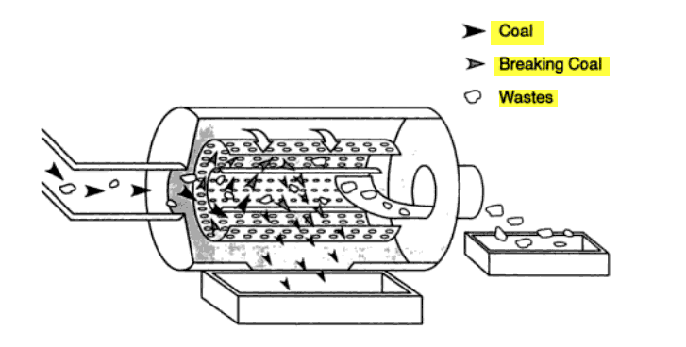

Fig. 5 A Typical View of Rotary Breaker Operation (legends correction)

The ROM coal is fed into the rotating cylinder. The small coal and shale quickly fall through the holes while the larger lumps are retained. Lifter bars attached to the cylinder lift up the lumps as the cylinder rotates. At the highest point, the lumps slide off the lifter bars and fall into the bottom of the cylinder, breaking by their own impact along natural cleavage lines. The broken material passes through the holes while the larger lumps are retained. The lifter bars are inclined to give the coal a slight forward impulse, so that there is motion through the breaker. Large pieces of shale do not break as easily as coal and are discharged from the end of the breaker. The breaker thus cleans the larger sizes of coal to a certain degree and as the broken coal is quickly removed from the breaker, generation of fines is minimal.

The advantages rotary breakers offer in handling ROM coal include initial size reduction, positive control of product top size and rejection of large obvious rocks – all being done by one single unit. These are relatively trouble free and reasonably priced pieces of capital equipment in comparison with gyratory or jaw crushers. Furthermore, maintenance and operating costs are relatively low, which is an advantage. When large throughputs are involved, scalping screens are often installed ahead of the breakers to remove undersize material and fines. With high throughputs, fines have a tendency to build up in the breakers, cushioning larger lumps of coal and reducing the retention time in the breaker, which can cause carry-over of not only discard but coal as well.

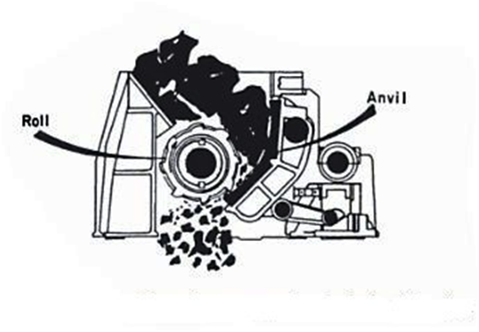

Fig. 6 Schematic Representation of Single Roll Crusher

Single Roll Crushers

The single roll crusher (SRC) is one of the oldest and perhaps simplest types of size reduction equipment. Designed for economical primary and secondary reduction of friable materials, SRC (Fig. 6) can reduce ROM coal even to a-38 mm product. It consists primarily of a heavy cast iron or steel fabricated frame on which is mounted a toothed roll and stationary breaker plate. The plate is curved to prevent the passage of slabby material. The single roll or cylinder is keyed to a single shaft driven by a flywheel. The shaft bearings may be spring mounted to give protection should un-crushable objects be introduced or the breaker plate can be spring loaded to allow un-crushable material to pass. All the teeth segments are renewable, being bolted to the cylinder. The breaker plate is provided with renewable wearing liners, which are bolted to the breaker plate. As further protection, the flywheel may be keyed to the shaft by shear pins.

The roll usually has long teeth equally spaced around and along the roll with short teeth inserted in the spaces between the long teeth. Coal is caught at an *angle of nip* (Fig 7) between the recovery roll and the breaker plate where the long teeth act as feeders and do the initial breakage of large lumps and the short teeth accomplish the final size reduction. The ‘angle of nip’ most frequently used in conjunction with double roll crushers, is the angle (Ɵ/ 2) formed by a spherical particle (lump) setting between two equal-diameter crusher rolls (D = 2R) or between a single roll and the breaker plate (in a SRC) or between the two jaws (in a jaw crusher) separated by a given distance. The angle of nip is a function of the coefficient of friction between the particle and crusher rolls, alternatively between the two opposing crushing faces. For a given lump size, the roll diameter and spacing must be chosen so that the angle of nip is large enough to prevent the particle from being thrown away from the crushing rolls.

Variation of tooth design helps to tailor the SRC to a particular feed. Product size adjustment is made by changing the clearance between crushing roll and breaker plate. Operating at slow speeds with the teeth moving at about 100m per minute, they are powerful and economical crushers utilizing mainly impact, shear and sometimes compression in their operation. SRC requires minimum head room and under proper conditions produce minimum of fines. Large units can crush ROM coal with a – 1220 mm top size to a product size of 80% passing 150 mm (Table 3). In smaller operations SRC can replace a rotary breaker. The crusher is installed with a scalping screen below it. All of the sized coal in the product will pass through the scalping screen. All discard that is passed through the crusher by way of the spring-loaded breaker plate, will be too large to pass through the scalping screen apertures and can be discarded. This is a very cost-effective option in smaller operations due to the relatively low capital outlay and the reduced space requirement in comparison to a rotary breaker or a reciprocating crusher.

Double Roll Crushers

**π-θ/2**

**r**

**R**

**θ/2**

**2a**

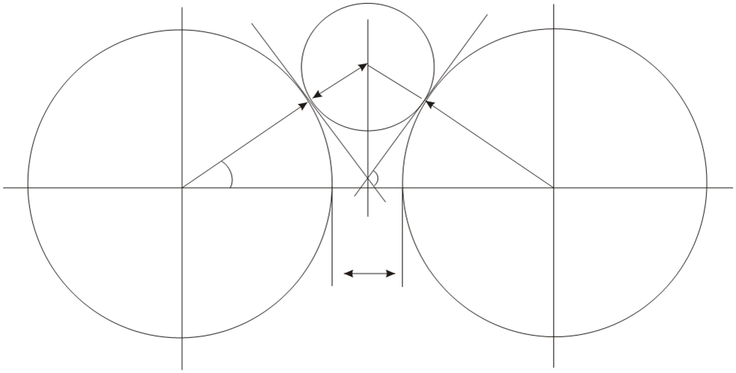

Fig. 7 Angle of Nip in a Double Roll Crusher

Double roll crushers (DRC) rely more on shear with a minimum of attrition, rather than by compression between the rolls. Any resulting compression between the rolls is highly undesired. It is a sign of improper maintenance or adjustment. The fact that compression plays a secondary role is evidenced by the production of a relatively small amount of fines. Adjustment of the spacing between the rolls is an important factor. Different mechanisms are available for this. One roll of the crusher is driven through a belt or chain, and the other is turned through a gear or chain from the driven roll. The unit essentially consists of these two cylindrical rolls revolving in opposite direction (Fig. 8). Popular tooth style producing a minimum of fines and dust includes the hawk-billed for primary crushing, and the pyramidal, cone-shaped and cross-tooth designs for secondary crushing. Smooth or corrugated roll can even be used for fine coal grinding or pulverization. DRC provides relatively high tonnage and accurate sizing, while at the same time producing a minimum of fines. The capacity of a unit depends on the roll speed, diameter and length of the rolls and their set.

Table 3 Salient Features of Some of the Major Crushers

|  |  |  |  |  |  |  |  |
| --- | --- | --- | --- | --- | --- | --- | --- |
| Crusher | Principal  Effect | Particle Size (mm) | | Throughput  TPH | Energy  kWh/ t | Suited  for Rocks | Unsuited  for Rocks |
| Feed | Product |
| Jaw crusher | Pressure | 150-1800 | 25-250 | 10-1000 | 0.2 - 0.7 | Hard and  medium hard | Soft and sticky |
| Gyratory crusher | 150-1800 | 25-250 | 35-3500 | 0.15 - 0.5 |
| Cone crusher | Pressure and blows | 25-650 | 5-40 | 10-600 | 0.4 - 2.2 |
| Smooth rolls | Pressure | 5-75 | 3-15 | 3-150 | 0.7 - 1.1 | Medium hard &  abrasive |  |
| Toothed rolls | Shear, impact and compression | 75-500 | 38/ 50-200 | 5-1000 | 0.15 - 0.4 | Friable | Hard |

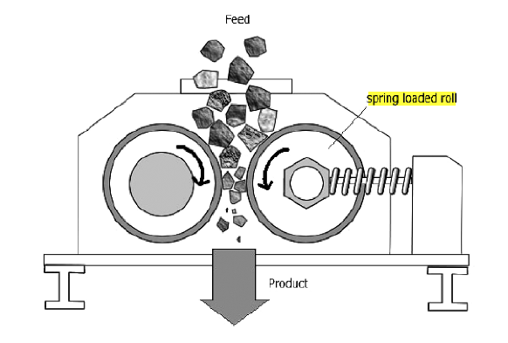

Fig. 8 A Functional Diagram of Double Roll Crusher

A variant of the conventional DRC is the Mineral Sizer. Designed to be of heavy duty and capable of taking feed rates up to 2500tph with a top size of 1.25m, the units have been used to crush rock as well as ROM coal to a product size not less than -40mm. The machines have twin shafts. The rolls may be fitted with a range of teeth or picks to suit the particular crushing requirement. For hard rock, however, special care needs to be taken of the power consumption and teeth design. In practice, the Sizers have not proved to be very economical on hard material.

Hammer Mills

Hammer mills consist of a heavy frame supporting a rotor to which hammers are attached. On one side of the rotor is the feed opening; on the other side are grate bars whose function is to fix the product top size. A metal trap is usually included to prevent damage to the hammers or cage bars by un-crushable material (Fig.9). In all hammer mills, the material is broken by impact from hammers striking the material and reducing it until it is fine enough to pass through the grated openings or screen plates. Generally speaking, heavy hammers operated at a lower speed are best for coarse crushing operations while a greater number of lighter hammers operated at a higher speed are best for crushing to finer sizes. Hammers, breaker plates and grate bars must be in good condition to maintain proper product size and efficient operation. The fineness obtained can be varied by adjustments of rpm or the spacing between the hammer tips and grate bars.

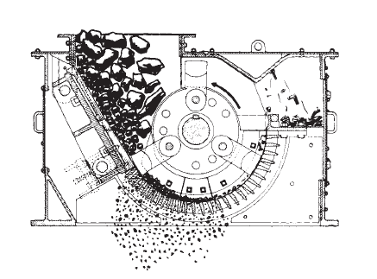

Fig.9 Simplified Sketch of a Non Reversible Hammer Mill

Ring Granulator

Ring granulators, also sometimes referred as ring crushers are similar to hammer mills, but use circular rings in place of swing hammers, both have breaker plates, rotor assemblies and cage assemblies. Rings may be toothed or of smooth design and are often used in combination. Most of the breaking action is by impact, compression crushing accounts for the remainder. A mechanism for cage position adjustment provides a method to compensate for the wear. Cage bar spacing may be altered for adjustment of product size. As with the hammer mill, the various parts which are subject to wear must be kept in good condition or replaced when necessary to ensure constant product size and optimum machine efficiency, primarily in terms of power consumption (Table 4)

# Table 4 Energy Requirement in Size- Reduction

|  |  |  |
| --- | --- | --- |
| Unit | Speed (rpm) | Specific energy  (kW/ tonne/ hr) |
| Rotary Breaker | 12-13 | 0.1 - 0.3 |
| Jaw Crusher | - | 0.2 - 0.5 |
| Single Roll Crusher | 40 - 60 | 0.2 - 0.6 |
| Double Roll Crusher | 115- 150 | 0.2 - 0.6 |
| Hammer Mills | 700- 1800 | 0.2 - 8.0 |
| Ring Granulators | - | 0.2 - 2.1 |
| Impactor | - | 0.5 - 20.0 |

Benefits in using primary impact-type crushers, as compared to compression crushers, are lower installed capital costs per ton of capacity, much greater capacity for weight of comparable jaw and gyratory crushers thus reducing installation cost and raising the feasibility for mobile units, production of more cubical product and generally, a finer product gradation. This may reduce the need for secondary crushing units.

Reciprocating Crushers

Among the reciprocating crushers, jaw and gyratory are used as primary crushers, jaw, gyratory and cone as secondary ones, whereas only cones as tertiary crushers. They each have their own distinctive operative characteristics. Jaw crushers operate by squeezing the rock between the fixed and the movable sides of a tapered cavity (Fig.10). Most Blake type machines have a crushing angle of about 27° between swing and stationary jaws. The principle on which, gyratory crushers (Fig.11) work is very simple. If a cone is mounted on the upper end of a vertical shaft and the top of the shaft is held stationary while the lower end is rotated eccentrically, the cone will also swing eccentrically. If the cone is enclosed in a suitable housing, it will swing toward and away from the housing walls as it rotates. If the cone and the housing walls are sufficiently strong and heavy, anything caught between them will be crushed. Besides the increased efficiency developed by the continuous crushing action and curved crushing faces, gyratory-type crushers have other advantages

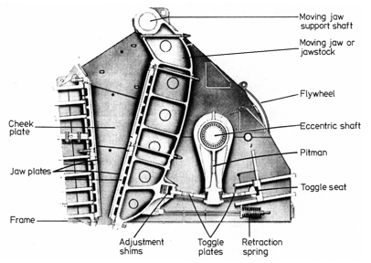

Fig.10 A Typical Jaw Crusher Construction

* The largest unrestricted feed opening available in comparison to other crusher types
* Capability to handle large feed sizes and wide range of feed rates; 600 - 6,000TPH
* The feed control is not always necessary. Direct dump trucks of 150 – 200t capacity are now being used in the larger installations.

The standard cone crusher (Fig.12) is normally applied as a secondary crusher in a multi-stage crushing circuit. The small diameter feed distributor and the wide throat opening at the top of the liners enable the crusher to accommodate the larger feed produced by the primary crusher. The short head cone crusher is normally applied as a third stage crusher in plants designed for three or four stages of crushing. However, the wide range of crushing cavities available in the short head crushers permits its installation as a secondary crusher in some cases. Maximum feed opening and product size ranges for the various models of short head cone crushers are 250mm and – 25 to -3mm, respectively. Maximum production will be obtained when the crusher operates at or near full horsepower load continuously. To achieve this condition, plant design, feed distribution and the type of crushing cavity are factors, which warrant considerations.

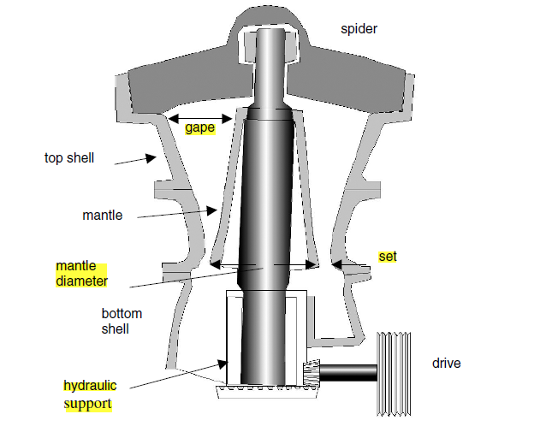

Fig.11 Functional Diagram of a Typical Gyratory Crusher

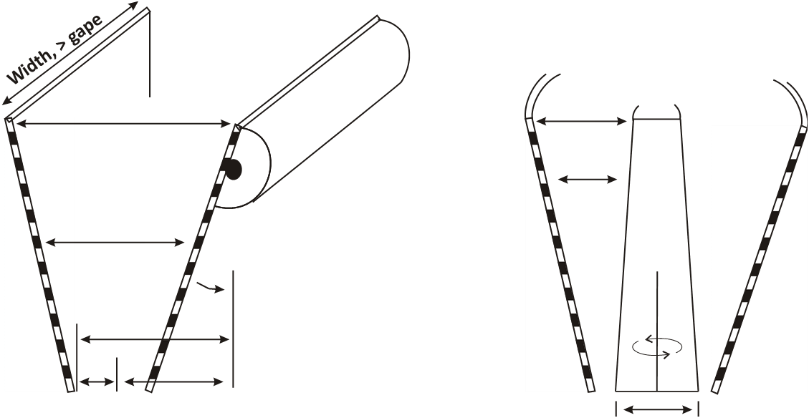

**Close side setting**

**Throw**

**Open side setting**

**Moving Jaw**

**Gape**

**Gape**

**Mantle diameter**

Fig. 13 Definitions of Reciprocating Crusher Openings; Jaw Crushers Normally Specified by Gape X Width, Gyratory Crushers by Gape X Mantle Diameter, Cone Crushers by Diameter of Feed Opening (Approximately 2 X Gape)

To meet variations in feed and product size requirements, the short head cone can be equipped with various designs of fine, medium and coarse crushing cavities. When the feed material is relatively nonabrasive, the crushing cavity selection is usually made to permit a condition where the entire cavity is filled up or “choked”. A certain degree of self-regulation takes place under these conditions. When crushing a material, which is both hard and abrasive, it is possible that the full motor power can be drawn without *having the crushing cavity entirely filled up or “choked”. After this initial “free* crushing”, as the crusher liners wear, the condition will develop where a “choked” cavity can be observed. The normal 10 to 30 kilowatt fluctuations in the tertiary position are much less than those observed in the secondary due to better control of feed consist and control.

Fig. 13 illustrates the nomenclature used by the manufacturers to designate the reciprocating crushers. Roll crushers are designated by roll diameter and width, which could be greater than the other depending on specific applications. Dimension of the feed opening designates the impact group of crushers, whereas for rotary breakers it is diameter and length.

Crushing Stages

To reduce ROM coal to wash plant feed or pulveriser feed in power plants requires reduction in a series of stages. As far as practicable, every crusher in each stage should operate on scalped feed basis. Scalping removes the material already crushed to the desired product size and thereby reduces the generation of fines and the actual crusher capacity requirement; thus reduces the capital cost of the crusher and its operating cost. The physical size and power requirement of a crusher capable of reducing hard coal vary depending on the application. Even when a crusher has the capability of achieving a high reduction ratio, it is normally more efficient to run the crusher at mid-setting (Table 3), rather than choosing the closest setting which offers the greatest reduction ratio. The main consideration at each stage for maximum production is efficient power draw. There is an optimum setting for each crusher and an optimum number of stages required for maximum plant production based on the individual characteristics of the material being crushed.

# Table 3 Preferred Reduction Ratios in Coal Crushing

|  |  |
| --- | --- |
| Crusher | Reduction Ratios (up to) |
| Gyratory | ≤8:1 |
| Standard Cone | 6 - 8: 1 |
| Short head | 4 - 6:1 |
| Single Roll Crusher | ≤7:1 |
| Double Roll Crusher | 3 - 5:1 |
| Hammer Mills | ≤20:1 |
| Ring Granulators | ≤40:1 |
| Impactor | ≤40:1 (closed circuit) |

Why to Crush Coal for Washing Purposes

For washing purposes, coal is crushed to liberate the mineral matter (impurities) present in coal (Fig. 14). These impurities do not burn and produce incombustible solid residue, known as ash. Coal is invariably washed at a specified ash to meet the requirement of consumers. Washing can be efficiently and economically carried out only if, ash forming mineral matters are, adequately liberated from coal, so that both can be effectively separated from each other. In an ideal scenario, one would strive for cent percent liberation, so that all the coal particles with little ash content could be recovered. That however becomes cost prohibitive. Liberation through successive stages of crushing is therefore carried out to the extent possible, as permitted by the total cost of washing; major process components being crushing, washing and moisture removal of washing products. It implies therefore, that liberation is an economic criteria and the degree or level of liberation is limited by ultimate cost of the whole process.



Fig. 14 Schematic Diagram of Coal Breakage and Resultant Liberation

Liberation can be most effective by promoting breakage along the boundaries between the mineral matter and the coal, known as grain boundaries. This however seldom happens, breakage being a random process with even a probability of a particle not being broken at all while passing through the crusher. If liberated along the grain boundaries, completely liberated coal and “rock” particles are obtained. These are easy to separate because of their specific gravity difference. Complete or close to complete liberation may also take place if selective breakage occurs (Fig. 14), e.g. in a rotary breaker or in a high speed hammer mill. Coal (say HGI 100) being relatively softer would break and the associated rock being relatively harder (say HGI 60) would not break. It could be the other way too, i.e. a relatively harder coal is accompanied by a relatively soft rock. Liberation would however remain incomplete if the smaller lumps produced continue to contain coal “locked” in rock and or rock “locked” in coal, which usually is the case (Fig. 14).

Fig. 15 Effect of Liberation on Yields of Clean Coal at a Specified Ash

Most commonly however, one single stage crushing by any crusher leads to grossly incomplete liberation. Successive stages of crushing are therefore carried out to ensure an economic level of liberation. When a ROM coal is finally crushed, e.g. to -75mm, crushed coal consists of weight percentages of material appearing in constituent size fractions, such as 75-50, 50-25, 25-13, 13-6, 6-3, 3-0.5 and -0.5mm, known as size distribution (Fig. 15). Each size fraction has a different degree of liberation, which increases with the successively decreasing sizes. Therefore, when these size fractions are washed, because of increased liberation, clean coal yield (% of feed reporting to a given product) at the same average ash content of 30% increases with those successively decreasing sizes. Degree of liberation attained is such that clean coal yield is only 26% for the coarsest size fraction of 75-50mm and 89% for the finest size fraction of 3-0.5mm. Let it be remembered that 30% average ash is typical for coal railed in India over a distance of more than 1000km. 86% is a very high yield but that could be obtained at 30% ash and only for the particles smaller than 3mm. This is in contrast to the coal from US, Canada, Australia and Europe, where ROM coal with a size of -300mm usually has the same average ash content of 30%. Limiting average ash of coal supplied to coal fired power plants in the US is 15%, average being 8-12%. Fig. 15 indicates that at 15% average ash, there would hardly be any clean coal in the size fractions 75-50 and 50-25 mm indicating effectively no or little liberation. Even at the size of 3-0.5mm, because of inadequate liberation the yield is only 53%, thus making the washing of this coal an un-economic preposition. This stark difference between Indian and say US coal in terms of size wise liberation in terms of ash content demonstrates why Indian coal is one of the most difficult to wash and why so much care is needed to crush Indian coal for washing purpose.

**GRINDING MILLS**



      

**SEMI-AUTOGENOUS AND AUTOGENOUS GRINDING**

INTRODUCTION

* Size reduction is the most expensive operation in mineral processing operations (60-70% ). Hence selection of proper crushing and grinding methods in flow sheet is very important.
* The use of Semiautogenous and Autogenous grinding has been increased recently, and are used when the ore differ in its hardness.
* Ingeneral autogenous or semiautogenous can replace all the communition steps after primary crusher and directly produce feed to further operations.
* But most of the times a pebble mill or ball mill is combined with semiautogenous or autogenous mill.
* Autogeneous single stage
* Autogeneous +ball mill+crusher
* Autogeneous +pebble mill
* Autogeneous +ball mill
* Semiautogeneous single stage
* Semiautogeneous +ball mill
* Different combinations are used for different specific purposes, and the best one is chosen as per the requirement.

   

SCREENING OF COAL - AN OUTLINE

Sizing is the division of a material into products between nominal size limits (IS: 3810 - Part I). Therefore, sizing or screening is the process of separating particles of differing sizes into groups in which all particles range between defined maximum and minimum size limits. The “size” of a non-uniformly shaped particle cannot be readily defined, but it can be described in terms of a surface opening through which a particle of that particular size will barely pass, or not pass at all. In other words, two openings, the smaller of which will retain all particles of the size group and the larger of which will pass all particles, will define a size range, e.g. -100+50mm. Before we move further, some of the terminology used in coal screening needs clarification.

* Screen Overflow: that portion of the feed material discharged from the screen deck without having passed through the apertures (IS: 3810 - Part I)
* Undersize (in an Overflow): particles in a screen overflow which are smaller than the nominal dimensions of the screen aperture (IS: 3810 - Part I)
* Screen Underflow: that portion of the feed material which has passed through the aperture in a screen deck (IS: 3810 - Part I)
* Oversize (in an Underflow): particles in a screen underflow which are larger than the nominal dimension of the screen apertures (IS: 3810 - Part I)
* Misplaced Materia1 (in screening): undersize contained in the overflow, or oversize contained in the underflow (IS: 3810 - Part I)
* Blinding: name given to the condition when the apertures of a screen become completely blocked with fine coal particles
* Raw Coal: coal which has received no preparation other than possibly preliminary screening and crushing (IS: 3810 - Part I), e.g. in a coal handling plant (CHP)
* Sized Coal: coal screened between specified size limits (IS: 3810 - Part I)
* Lump Coal: fraction of ROM coal retained on 600mm screen, without any upper size limit (IS: 3810 - Part I)
* Large Coal (Steam Coal): fraction of ROM or raw coal passing through 200mm screen but retained on 40mm screen (IS: 3810 - Part I)
* Medium Coal: fraction of ROM or raw coal passing through 50mm screen but retained on 25mm screen (IS: 3810 - Part I)
* Small Coal: fraction of run-or-mine or raw coal passing through 25mm screen but retained on 12.5mm screen (IS: 3810 - Part I)
* Slack Coal: coal with a specified top size, usually below 50mm, and no lower size limit, sold as washed, cleaned or untreated slack (IS: 3810 - Part I)
* Coarse coal: normally coal larger than about 6 mm (SA thumb rule)
* Small coal: coal intermediate in size between coarse and fine coal, i.e. coal having a size within the range of about 15 mm and 0.5 mm (SA thumb rule)
* Fine Coal: coal having a maximum particle size usually less than 3mm (IS: 3810 - Part I)
* Fines: fraction of ROM or raw coal passing through 0.5mm screen (IS: 3810 - Part I)
* Ultra Fine Coal: Fraction of ROM or crushed raw coal passing through 53micron IS sieve (IS: 3810 - Part I)
* Pegging (chocking): blockage of the screen apertures by Near Size Particles that become lodged in the openings (often slabby, conical or carrot shaped); particle shape playing important role
* Near Mesh Material: material approximating in size to the mesh aperture (IS: 3810 - Part I)
* Near Size (Mesh) Particles in coarse screening: between ½ (3/4) to 1½ times the aperture size
* Near Size (Mesh) Particles in fine screening: 2- mesh size equivalents larger and smaller than the opening
* Coarse screening: when size separations are made at 4mesh (4.75mm) or larger (US thumb rule)
* Dry screening: the screening of solid materials of different sizes without the aid of water(IS: 3810 - Part I); dry screening below 6mesh is typically not a commercial success, because of capacity constraint
* Separation Size: actual cut-point at which size-separation is effected according to Tromp. This is the particle size of that infinitely small size fraction which has entered in equal proportions into overflow and underflow products of the screen (IS: 3810 - Part I); also known as Cut size: the actual size of coal that will pass through a particular aperture size; typically 20% smaller than the aperture size
* Maximum screen efficiency achievable, in coarse screening is 95% attained at 80% of the rated capacity (also known as design capacity: the rate of feed, defined by limits expressing the extent and duration of load variations, at which specific items of plant subject to a performance guarantee must operate continuously and given the guaranteed results on a particular quality of feed (IS: 3810 - Part I).

Introduction

There is a wide range of purposes for screening. The main purposes in the coal industry are:

1. to prevent the entry of undersize into crushers, so increasing their capacity and efficiency,
2. to prevent oversize material from passing to the next stage in closed-circuit fine crushing and grinding operations,
3. to prepare a closely sized feed to coal washing processes,
4. to produce a closely sized end product.

Sizing of coal relies on the mechanical process of presenting a feed material to a screen surface (Fig.1). Commercial screening, which is a continuous process, results in imperfect separations. A perfect separation is that, when all the particles capable of passing through the screen have actually passed through. Commercial screening is seldom designed to achieve perfect separation. It involves two basic processes. Stratification, the process whereby the large particles rise to the top of the vibrating material bed while the small particles shift through the voids and find their way to the bottom of the bed. Probability of separation is the process whereby particles present themselves to aperture through repeated falls and are rejected if larger than the opening or passed through if smaller.

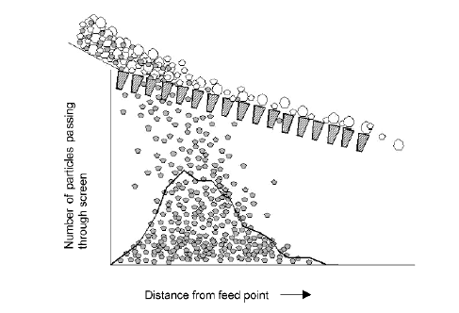

Figure 1 Particle size distribution during a screening operation and the profile of screened undersize

Since the purpose of screening is to remove the fine material form the feed to a screen, screen efficiency (E) expressed in % can be determined in the following manner.

Amount of fines in feed reporting to undersize

E =

Amount of fines in feed

Efficiency for coarser fractions can also be calculated in similar manner with respect to oversize.

Factors Affecting Screen Performance

*Material Factors*

* Bulk density
* Shape of feed size distribution curve
* Relative size of particle and aperture
* Shape of particles
* Surface moisture

*Machine Factors*

* Screen surface: aperture shape, area and percentage open area
* Vibration: amplitude and frequency
* Angle of inclination
* Method of feeding screen and bed depth

FEED SIZE DISTRIBUTION

The particles of sizes relatively near the size of the apertures are those that are most difficult to separate in a screening operation. Near-size material consists of particles within a size range that varies from slightly smaller than the apertures to slightly larger than the apertures. The higher the percentage of this material present in the feed, the more difficult the screening operation becomes. Disproportionate percentage of coarser and finer fractions in feed also poses problems in screening.

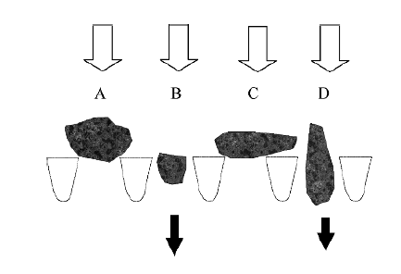

Figure 2 Behaviour of particle size and shape at screen surface

* Particle A is too big to pass through in any orientation;
* Particle B will pass in any orientation;
* Elongated particles can pass through only in orientation D
* But not if it lies flat on the screen in orientation C.

PARTICLE SIZE AND SHAPE

During the process of screening, particles on the screen deck encounter the apertures where they either fall through or are held back. Obviously particles larger than the aperture opening cannot pass through and move towards the discharge end. A fraction of particles, although smaller than the aperture also do not pass through the first time they encounter an aperture as they fall across the apertures and are held back. In subsequent encounters as the bed is loosened, the probability of passing through is increased. Particles that are flaky, which is typical for coal, are more likely to have similar problems. Particles that are elongated, but with cross section less than the aperture, will pass through provided they approach the aperture at an appropriate angle, ideal orientation being right angle. Thus both shape and size of particles are of importance in a screening operation (Fig 2). Particle sizes that are near to the aperture size, Near Size (Mesh) Particles, are the most difficult to screen.

FEED MOISTURE AND DRY VERSUS WET SCREENING

The definition of dry screening is any screening that takes place where water is not added into the feed or via spray water. Therefore, if the material has high moisture content and needs to be screened and no additional water is added, it is still considered to be dry screening. Conversely wet screening has water added to the feed or the feed may already be in a slurry form. Spray water may also be used.

Run-of-mine coal is very seldom dry, and with the use of water to suppress dust formation, feed normally contains about 5% - 10% surface moisture. It is quite common that a gradual build-up of material takes place on the screen as the result of damp particles sticking to the screen, so that eventually the screen apertures become blocked. That might even lead to the formation of a complete cover over the screen surface, known as blanketing. The size of the particles causing the bridging can be very much smaller than the size of the screen aperture. Blinding usually occurs when the moisture content is more than 5% and less than 20%. Above 20% the moisture content will aid the screening process. Because of increased surface area, fine coal carries more surface moisture than coarse coal. When fines are being screened, the surface moisture can considerably affect the screening efficiency, particularly in presence of clay. A certain amount of moisture will cause the fine coal to stick together and to form small agglomerates, or to stick to the larger particles and so pass over the screening media instead of through it. Wet screening will overcome the problem and greatly increase the efficiency of screening. High-pressure water sprays on the screen deck are employed for this purpose.

Screens of high-frequency vibration and low amplitude of throw are employed for dry screening. Nevertheless, dry screening is not employed for sizes smaller then 6mm and in some cases, even 13mm. For certain coal uses, e.g. cement manufacture, wet screening is undesirable, as the resulting small coal carries far too much moisture for the particular end-use. Hence a great deal of attention has been devoted to developing methods of screening smalls and fines out of damp coal. If the temperature of the screen deck can be raised slightly, the stickiness of the material tends to be decreased. In the heated deck screen, the whole of the mesh is heated by the passage of an electric current, thus reducing the ability of the damp fines to bridge over the gap. Sta-Kleen decks have normal mesh apertures, but captive rubber balls are mounted beneath the deck. As the screen vibrates, the balls strike the mesh and destroy the bridges of fine particles. The screening wire surfaces of piano-wire decks are formed of individually tensioned pieces of piano wire running in a direction parallel to the coal flow and supported at intervals. The individual vibrations of the piano wires tend to destroy any bridges created over the gap. Also available are other screen surface profiles to address the problem of blinding.

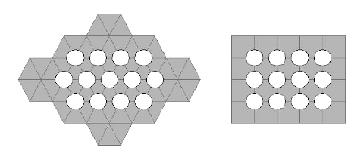

a

b

Figure 3 Screen perforation patterns on plates: a - circular apertures on a 60° pattern; b – circular apertures on a square pattern;

SCREEN SURFACES

The screen surface is the medium that contains the apertures for the passage of undersize material, and is therefore the most vital part of any screen. Such surface, as a result must fulfill certain basic requirements. The surface must be

* strong enough to support the weight of material being screened – *bulk density playing its role*
* flexible enough to yield to the vibrating forces applied to it
* light enough to provide a reasonable percentage of open area to give a practical throughput

The perforated plate surface made by punching apertures in steel plate is the most widely used in coal crushing plants. It wears generally longer and is stronger and more rigid. It is however heavier and has a lower capacity. Plates made of plain carbon or alloy steels, including stainless steel are used to make perforated screens. Holes are punched, drilled or cast directly during the manufacturing process of the sheets. Shape of the apertures is usually circular, square, or rectangular. The circular holes are equally spaced at the corners of an equilateral triangle or at the four corners of a square or elongated rectangular pattern (Fig.3). Hole spacing at 60° are common. Several variations of patterns are industrially available, like staggered squares, holes or slots or combinations of squares and rectangles. The perforated plates are often rubber and polyurethane clad with reasonable success. The rubber sheets have apertures slightly larger than the base plate. The holes in the rubber conform to the product size. The rubber cladding helps to absorb the force of impact of feed material falling onto the screen. *In this case too, bulk density of feed plays its role.* Rubber cladding also retard abrasion of the steel and promote a longer screen life. The elasticity of the rubber helps to reduce blinding of the screens. An added advantage of rubber-clad screens is a considerable reduction of noise level.

Woven wire cloth is made of a wide variety of metals and alloys. It is comparatively lighter but has a higher capacity. The patterns of weaves are usually square, but rectangular weaves with length to width ratio of 2 or more are also common in the coal industry abroad. Fig. 4 shows a woven screen cloth with square openings and the rectangular aperture of a typical profile bar screen. Available screening area (A1 or A2) is the space between the materials (wires, profile bars, rods, etc) forming the aperture. This space is expressed as a percent of the total area of the screen and is known as percentage open area. When the screens are set at an angle ø to the horizontal then the effective aperture will be diminished and will be equal to the projection of the actual screen aperture. The available area will then be modified as “Area x Cos ø”. Rod screens and profile bar surfaces constructed of stainless steel are being increasingly used to provide long life and to reduce the problem of blinding and clogging.

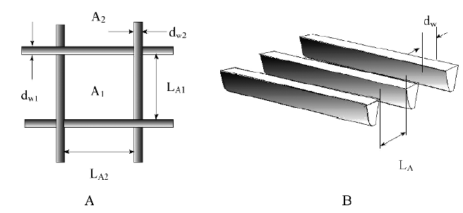

Figure 4 A - square or rectangular opening between wires, bars or strips; B - Parallel openings between wedge wires (d w: wire diameter; L a: aperture size)

.

Shape of the opening is another important factor. Commonly found shapes are round (Fig.3), square and rectangular (Fig.4). Perforated plate offers all the three shapes. Square and rectangular shapes can be obtained with woven wire surface, whereas round and triangular can be obtained with profile bar surface. Round openings are used, when top-size of the screen undersize is to be maintained, even at the cost of throughput. Square shape ensures high throughput and fairly accurate sizing. Rectangular shape offers higher throughput, sacrificing, however, the accuracy in sizing. Profile bars also known as slotted openings (Fig.4) are preferred, when feed contains high percentage of near size particles. Short slot length is typically 3 - 4 times the aperture width), whereas long slot length is typically more than 4 times the aperture width.

ANGLE OF INCLINATION

The inclination or slope (Fig. 1) is to assist material transport and is consistent with the angle of repose of the material. A relatively steep installation is preferred for higher throughputs through faster material movement aided by gravity but the quality of separation is likely to be affected as the effective aperture and open area are decreased. Moreover, the particles are on the screen for less time (reduced residence time) and therefore have less chance of passing through the apertures. An aperture above the separation size can be selected to overcome this problem.

Secondly, the increase in speed reduces the bed thickness on the screen for a given feed tonnage thus improving stratification. Hence, the capacity of the screen will be increased to some extent. To have both high capacity and good screening efficiency, an inclined screen needs to be long enough for near size particles to have sufficient opportunity to pass through the apertures. There is a limit to the extent to which this increase in capacity is acceptable as eventually the particles travel so quickly that they bounce over the screen surface, even if smaller than the apertures, instead of finding their way through the apertures. The overall effect of this is that the size at which the screen cuts is reduced, even though the apertures themselves are unchanged. It could be, for example, that with apertures of 20mm, only particles of less than 1.5mm in size can find their way through the screen deck, if the slope of the screen is too great.

VIBRATION

The speed of vibration (frequency) of a screen affects both the efficiency and the capacity of a screen. Throw or stroke (twice the amplitude) is the distance a particle is lifted off the screen deck by the drive of the screen. It is measured in millimeters and normally consists of a vertical and horizontal component to achieve lift and forward motion. The size of the throw or stroke relative to the aperture size is a critical component of vibrating screens. Each stroke or vibration causes the material to travel further towards the discharge end, whereas “lifting off opens” the bed and allows the undersize to pass through the screen media (Fig. 1). Thus increasing the speed, causing the bed to “open” more frequently increases the efficiency of the screen.

It follows that increasing the speed and maintaining the same efficiency increases the capacity of the screen. There are limitations, however, to increasing the speed of screens, because the faster the screen vibrates, the greater the stress set up in the bearings and frame. This has the effect of shortening the life of the screen and increasing maintenance on it. An additional drawback to increasing the screen speed is that above certain speed levels (which can only really be found by experiment), particles trying to pass through an aperture may strike the edge of the aperture and be flung back into the bed, hence reducing the efficiency of screening. The particles generally move forward one-half to one aperture per vibration. Maximum height of the particle trajectory should occur when the screen surface is as its lowest point. From whatever has been stated here before it follows that there is an optimum frequency and amplitude of vibration (Fig. 5). Furthermore, the frequency of vibration must decrease and the amplitude must increase as the aperture size increases.

If the throw or stroke is too small, the apertures will tend to peg or blind with material. Too large a throw will tend to cause breakage in the coal being screened and also reduce the changes of the particle passing through the apertures. The throw of a screen is made up of two components, the speed of the screen’s drive and the centrifugal force produced by the drive in relationship to the mass of the screen. Typically screens operate at a “gravitational force” of between 3, 5 and 5.0 G’s on an inclined screen and 4, 5 and 5.0 G’s on a horizontal screen. As a rule of thumb the stroke should be longer for large apertures and shorter for small apertures but the G force must remain within the limits set out above.



**Percent** **Passing**

***Vibrations per minute***

**Amplitude**

**Frequency**

0.3

0.4

0.5

0.6

0.7

0.8

0

70

60

50

40

0

0

1000

1400

1800

Figure 5 Dependence of Material Flow through on Vibration

SCREEN FEEDING

The feed arrangement to a screen is critical to its performance because if fed incorrectly, poor efficiency will result. Feed arrangements must be designed to ensure the even spread of material over the full width of the screen deck and forward velocity of the particles controlled to achieve acceptable efficiencies. Poor feed chute design is probably the major cause of poor screening efficiency in the coal industry.

Screen

Surface

Screen Length

Feed Pan

Feed

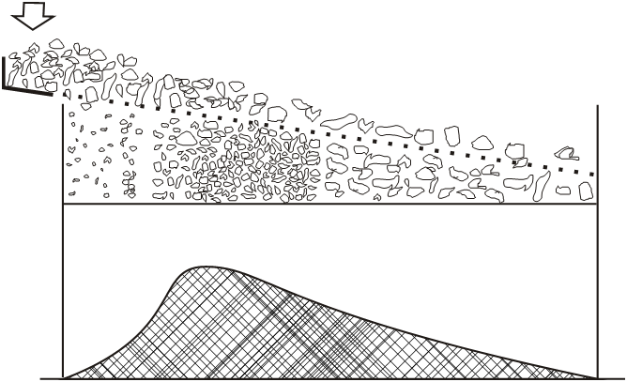

III

II

I

Rate of Flow Through

Figure 6 Three Major Regions Occurring along a Screening Surface in Chocked Screening

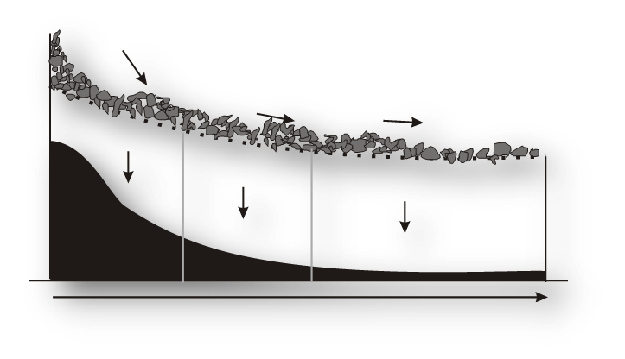

3-4 m/s

**1-2 m/s**

**0.5-0.8 m/s**

3-4 m/s

**Zone 1**

**Zone 2**

**Zone 3**

Figure 7 Three Major Regions Occurring along a Screening Surface in Free Screening (axis same as in Fig. 6)

A screen can be fed in two modes; choked feeding leading to choked screening and free feeding leading to free screening. In the former one, material flow through the apertures is lowest in the initial region because of high initial bed depth (Fig. 6), reaches maximum in the intermediate region because of the loosening of the bed and then gradually decreases towards the discharge end. In free screening, material flow through the apertures are maximum in the initial region itself because of bed voidage facilitating sifting of smaller particles through to the screen surface (Fig. 7) and then gradually decreases towards the discharge end. A screen therefore, must be designed and constructed in such a way that the screening operation can be done at a particular feed rate and at high efficiency; the wider a screen, the greater its capacity and the longer a screen, the higher its efficiency.

In addition to feed bed depth, the discharge bed depth of the material is also critical to efficient screening. As a rule of thumb, to achieve acceptable screening efficiencies, the discharge bed depth should be three times the screening media aperture size. If the discharge bed depth is less than three times the aperture size, material will tend to bounce on the screening media as there is insufficient material to hold it down. This causes the coal particles to be misplaced resulting in poor screening efficiencies. Conversely if the discharge bed depth is greater than three times the aperture size, poor stratification takes place resulting to reduced screening efficiency as a result of a carry-over of fines.

Screens

IS: 3810 (Part I) classifies the screens used in coal preparation according to purpose in the following manner.

Raw Coal Screen: a screen used for dividing ROM coal into two or more sizes for further treatment or disposal; usually employed to remove the largest pieces for crushing and re-addition to the ROM coal

Primary Screen: a screen used to divide coal (usually raw coal) into sizes more suitable for subsequent cleaning of some or all of them

De-watering Screen: a screen used for the separation of water from solids

De-sliming Screen: a screen used for the removal of slime from larger particles, usually with the aid of water sprays

Slurry Screen: a screen to recover solid product from circulating water in a washer, usually after preliminary concentration of the solids and with or without the use of water sprays

Spraying Screen: a screen used for the removal by spraying of fines present among or adhering to larger particles

Pre-sizing Screen: a screen used to remove under-sizes from the feed to a washing unit

Sizing Screen (s) [Grading Screen (s), Classifying Screen (s)]: a screen or set of screens normally used for dividing a product (such as washed coal) into a range of sizes

Oversize Control Screen (Guard Screen, Check Screen): a screen used to prevent the entry into a machine of coarse particles which might interfere with its operation

Undersize Control Screen: a screen used for the removal of under size from a product

Grizzly: a rugged screen for rough sizing at a comparatively large size (such as 150mm); it can comprise of fixed or moving bars, discs, or shaped tumblers or rollers

Grizzlies

Screens used in coal crushing plants therefore can be broadly divided into two groups. The first group is popularly known as scalping screens and used for scalping fines from crusher feed. Grizzlies and scalpers belong to this group. The other group is essentially vibrating screens and is popularly known as ROM or raw coal sizing screens.

Grizzlies are simple and robust, can be stationary and vibrating, but will never possibly be more than 75% efficient. Grizzlies and coarse scalping screens are generally fabricated by welding steel rails, rods or bars forming grids of a desired pattern. The selection of rails varies in size from about 7.4 kg/m to about 225 kg/m, *depending on bulk density of the feed* and ROM coal discharge rate and height. The rails usually run parallel to each other for the entire length of the screening surface. The spacing in between are of the order of 5 - 200 mm. For smooth flow of materials the openings are tapered, the top being wider than the bottom. Heavy-duty grizzly bars are cast from manganese steel having double tapers. These are designed to receive ROM coal from railroad wagons, tipper cars, dumpers and other bulk material handling systems that discharge from considerable heights. They are therefore very robustly built. The rail grizzlies can be installed to operate in a horizontal flat plane, but they are often inclined to aid transport of coal across the screen. The inclination is of the order of 30 - 40°. For sticky coal, because of clay or moisture or both, the inclination could be up to 45°. For very sticky coal, vibrators are employed to facilitate continuous operation. Otherwise, vibrating grizzlies also known as roll grizzley or scalping roll are used. These are essentially a surface of rotating rolls and therefore, cannot be used for a large top-size of ROM coal.

Vibrating Screens

Vibrating screens are designed for specific purposes i.e. to process material (coal) within a specific size range, at a specific feed rate and a limited stroke range. They are normally of welded or of “Huck Bolted” construction. The main function of a sizing screen is to pass undersize particles from a feed through the apertures and to retain the oversize coal. This must be done at a stated efficiency and planned feed rate; design and construction must comply with this basic requirement. The maintenance costs and power consumption per ton of coal treated must be as low as possible.

Vibrating screens are mainly of two types: the low speed vibrators (300 – 700 r/min, with strokes from 25 to 32mm) and high-speed vibrators (700 - 2000 r/min, with strokes less than 17 mm). There are six main types of vibrating screens:

* Linear motion horizontal screens
* Linear motion inclined screens (15 to 28º downwards)
* Linear motion multi-slope screens (banana type)
* Circular motion inclined screens (15 to 28° downwards)
* Elliptical motion inclined screens ( 10 to 28º downwards)
* Resonance screens (according to IS: 3810 (Part I), it is a jigging screen, the period of oscillation of which is at or very close to the natural period of oscillation of the resilient mounting.)

Some Common Conversion Factors in Crushing and Screening

Pound per ft3 x 16.02=kilogram per m3;short ton x 0.91=metric ton; inch x 25.4=mm;

Foot x 0.305=meter; Kilowatt x 1.341=horsepower

**SCREENING**

The type of screening equipment may differ depending on the screening objectives which can be

1. Sizing or Classifying: To separate particles based on their size to provide particles of size suited for subsequent unit operations.
2. Scalping: To remove the coarser size fraction from the feed material usually to be crushed.
3. Grading: To prepare a number of products of specified size ranges.
4. Media Recovery: For washing magnetic media from coal and ore in Dense Media Circuits.
5. Dewatering: To drain out free moisture from wet sand or slurry.
6. Desliming or De-dusting: To remove fine material, generally -0.5mm material from dry or wet feed or from air.
7. Trash Removal: to remove wood fibres and other foreign objects, if any, from a fine slurry stream.

Basic Design features in Screens

Surface and aperture,

* 1. Coarse Screen Surface - Grizzly
  2. Woven Wire Screens
  3. Wedge Wire Screens
  4. Perforated Steel Plates
  5. Rubber Screens
  6. Elastic Polyurethane Screens
  7. Derrick urethane screens
  8. SWG™ Sandwich Screen®
  9. Floating Backing Wire
  10. Pyramid Screens™

**CLASSIFICATION**

classification can be defined as: the method of separation or concentration by difference in the settling rate due to variation of particle size shape and density in a fluid medium is know as classification.

• Fluid medium :here fluid medium is water but in modified condition such as rising at uniform rate , changing density , addition of suitable reagent , and passing air bubble .

• Classifier consists of a sorting column in which a fluid rises at uniform rate ,particles introduced into the shorting column sink and report as underflow if their terminal velocity are greater than the velocity of water , and in other hand if their terminal velocity is less than upward velocity of the fluid , it rises and report as over flow.

**Spiral and rake classifier:** mechanically driven devices

• The unit drag coarser sandy sediments from the settled feed pulp by a continuously revolving spiral along the bottom of an inclined surface to a high discharge point on one end of the settling tank the fines over flow at the other end .

• Rake classifier is a variation in the mechanism of shifting the coarser component .the rake dip into the feed pulp ,move in an eccentric motion along an inclined plane for a short distance then lift it up and go back to the starting point to repeat the operation

• Spiral classifier are prefer over rake as the material does not slides backward.

**BENEFICIATION USING HYDRO CYCLONES**

Materials of hydro cyclone:-

1. Steel Cast

2. Aluminium

3. Fiber glass

4. urethane

5. Stainless steel

Materials of liners:-

1. Natural Gum Rubber

2. Synthetic Rubber

3. Urethane

4. Nitride bonded silicon carbide

Selection of cyclone:-

Cyclone selection for any circuit is done by selecting following parameter of cyclone.

1. Cyclone diameter

X50= 13.2D0.675exp(-.301+.0945V-.00356V2+.000064V3)

(▲P).3 √(ρ-1)

Where X50 is separation size

D is cyclone diameter

V is volume percent solid(m3/s)

2. Volume of cyclone

Q= 0.7 D2√(▲P)

3. Vortex diameter

vortex diameter= 0.4xD

4. Apex diameter

S= 4.162― 16.43 +1.1ln(U/ρ)

(2.65―ρ+100ρ/ρu)

Where U is the underflow solid tonnage

ρu is underflow percent solid by weight

5. Inlet area

inlet area= 7% of the cross sectional area of the feed chamber

Advantage:-

1. More efficient (finer size range)

2.Less floor space

3.Less residence time of particle within the cyclone

4.Oxidation of particle is reduced within the circuit

5.Mill circuit can rapidly be brought into balance

6.Low maintenance

**TERMINAL VELOCITY (SETTLING VELOCITY)**

Consider a spherical particle of dia d and density Ds falling under gravity in a viscous fluid of density Df under free settling conditions, ideally in a fluid of infinite extent. The particle is a toward s the centre axis of the cone and reverse its axial

**Stocks law and terminal velocity(settling velocity)**

Consider a spherical particle of dia d and density Ds falling under gravity in a viscous fluid of density Df under free settling conditions, ideally in a fluid of infinite extent. The particle is acted three forces

1- a gravitational force acting acting downwards

2-an upward buoyant force due to the displaced fluid

3-a drag force d acting upwards

d- diameter of spherical particle

Ds- density of solid

Df- density of fluid

M’-mass of the displaced liquid

M- mass of the particle

X- partial velocity

Equation of motion of particle is given by

Gravitational force – buoyant force – drag force = m dx/dt

mg - m’g – D = M dx/dt

At terminal velocity that is when upward force is equal to downward (x tend to 0)

That is dx/dt = 0

g(m-m’) – D = m . Zero

g(m-m) – D = 0

D = g (m – m’)

We know that density = mass/volume

So mass is equal to density x volume

D = g (Ds.v – Df .v)

D = gv (Ds – Df )

= g [ 4/3 π (d/2)3 ] ( Ds – Df ) = g1/6 π d3 ( Ds – Df )

Stocks assumed that the drag force on the a sphere particle to be entirely due to viscous resistance and deduced the expression. D= 3 π d η V

Here η = fluid velocity

V= terminal velocity 3 π d η V = π/6 g d3 (Ds – Df) V = g d 2 (Ds – Df) / 18 η

This expression is called stokes law

Newton assumed that the drag force was entirely due to turbulent resistance and deduced D= 0.55 π d 2 v 2 Df 0.55 π d 2 v 2 Df = π/6 g d3 (Ds – Df)

V = (3gd (Ds-Df)/Df)1/2

Stokes' law makes the following assumptions for the behaviour of a particle in a fluid:

1-Laminar Flow

2-Spherical particles

3-Homogeneous (uniform in composition) material

4-Smooth surfaces

5-Particles do not interfere with each other.

**Stokes law vs newton's law**

Stockes law is valid for particles of size below about 50micrometer in dia.

The upper size limit is determined by dimensionless reylond number .

Newtons law is valid for particles of size greater than 0.5 cm in dia

**GRAVITY SEPARATION OPERATION**

1- Jigging - in this process the bed of ore particle is vertically expanded or contract by help of fluid .

2- Shaking concentrators: employs a horizontal motion to the solid fluid stream to effetely fluidised the particle causing segregation of light and heavy particles.

3- Flowing film concentrator: initiate particle separation by a layer of slurry flowing down an inclined surface under influence of gravity. Some of the oldest knows concentrator

**JIGS PROCESS**

In a jig it consists of a perforated bed with a bed of different size particles . Stratification occurs due to expansion and contraction of the bed due to pulsation of fluid upward through the bed , this pulsation is done in acyclic manner (50- 300 cycles per min ) due to this heavier particles and lighter particles get stratified .

**Principle of jigging:**

Three factors responsible for stratification of particles during jigging are

1. Hinder settling
2. 2-differentaial acceleration at the beginning of the fall
3. Consolidation trickling at the end of the fall

**Jigging vs classification**

In jigging the solid fluid mixture is very thick and it approximates to a closed packed bed of solid with interstitial fluid flowing through the particle rather than the fluid carrying the solid particle with it as in case of classifie.

**Jigging cycle :** It consist of pulsion and suction in case of pulsion the fluid moved upward through the bed of particles ,the bed expanded (fluidised ) and in suction the fluid return back downwards . A complete cycle of of one suction and one pulsion is know as jigging cycle Most jigs used pulsion and suction both but in some jigs only pulsion is used.

**Jigs types**

1. hand jigs – consist of rope pulley and perforated cylindrical vessel . Here the jigs is vertically moved in water medium to carry out jigging process.
2. mechanical jigs – shallow open tank containing a screen bottom on which ore is to be supported , a hydraulic water chamber , a reciprocationg system for pulsion and suction of water through screen.

**Uses of jigs :**

1. Used for cleaning coal

2. Heavy media separation including alluvial gold • While treating coal and mineral the lighter particle is concentrate for coal and heavy fraction is concentrate for mineral • For this very reason gravity separation is product is called light or heavy rather than concentrate or tailings.

**WILFLEY TABLE :**

1. It consist of slightly inclined flat surface or deck with a series of parallel ridges and riffles along the direction of motion .
2. The riffles are tapered towards the opposite end of the reciprocating drive.
3. Feed is introduced at the corner of the table at abou per cent solid (by mass)and with the shaking motion , the particles spread out over the table
4. Water is introduced along the top edge of the deck to assist segregating and transport of particles on the table.
5. Due to this the particles moves diagon deck from the feed end.
6. As the feed material spreads out over the table the particles stratified in layers behinds the riffle.
7. The riffles help to transmit the shaking motion to the particle and prevent the particle washing directly off t table.
8. Here if the table operates in a correct manner then the middling’s fraction discharge at the diagonally opposite corner of the table to the feed.
9. Size separation will be very difficult it there is range of size increases

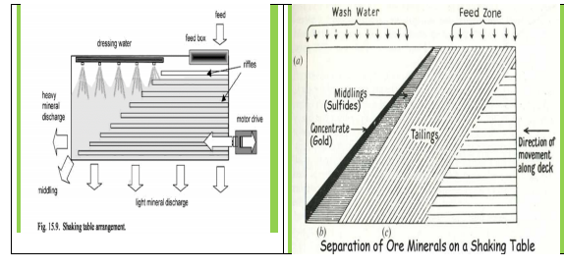

**Operating parameters**

1. Particles size , shape

2. particles density

3. deck shape

4. riffle design

5. water and feed flow

6. stroke and speed of the table and deck slope.

The lower size limit for an effective separation on a table is about 50 micro meter even if the density difference is high • For optimum table operation the feed flow of solids and water onto the table must be uniform and constant

**FLOWING FILM CONCENTRATOR:**

Fluid flow can be classified into three categories:

1. laminar or stream line flow [ Re <= 2100 ]

2. turbulent or eddy flow[ Re >= 4000 ]

3. mixed flow –combination of laminar and turbulent flow [ 2100 <= Re <= 4000 • Re= average velocity x diameter x kinematic viscosity

Kinematics viscosity = viscosity of the fluid / specific gravity of the fluid

1-liquid films under laminar flow have specific mechanical properties that can be easily adopted to separate the mineral according to their specific gravity.

2-Specific mechanical property is that , the velocity of the fluid is not the same at all depth of the film . •

1. suppose we consider a fluid flowing in a rectangular open channels then the fluid velocity at the bottom of the depth at A is nil and is maximum at the top B . similarly in case of a pipe the flow is maximum along the central axis and nil at the inner periphery of the pipe .
2. This property in turn depends upon the viscosity of the fluid . • Experimental facts of flowing film concentrate can be summarized as follows: • 1-fine- heavy particles • 2-coarser- heavy and fine light particles • 3-coarser – light particles • It is interesting to note that flowing film concentrate places the coarser heavy particle with the fine light particle . this is reverse of stratification that takes place during jigging .

**HEAVY MEDIA SEPARATION OR DENSE MEDIA SEPARATION : ( HMS)OR (DMS)**

1-Also called sink float separation .

2- Here a fluid (medium) is used whose density lies between the density of two mineral

3- Here the lighter mineral will float in the fluid medium and the heavy mineral will sink It is a special concentration process which mainly depend upon specific gravity. Here particle size do not come into account. In this process the mineral is put into a fluid whose specific gravity lies in between the specific gravities of the two minerals that are to be If there are more than two mineral in an ore then the heavy mineral is generally recovered as sink and the waste as float. For example the most metallic oxide lies in the range 4.5 gm/cc, silica the main component of density of 2.65 gm/cc. we use a heavy media whose density is 3.gm/cc , here the metallic oxdie sink but silica flot. Generally heavy minerals or alloys grounded up to size are normaly used . examples are galena , and ferro silicon.

**FROTH FLOTATION – FUNDAMENTAL PRINCIPLES**

Froth flotation is a highly versatile method for physically separating particles based on differences in the ability of air bubbles to selectively adhere to specific mineral surfaces in a mineral/water slurry. The particles with attached air bubbles are then carried to the surface and removed, while the particles that remain completely wetted stay in the liquid phase. Froth flotation can be adapted to a broad range of mineral separations, as it is possible to use chemical treatments to selectively alter mineral surfaces so that they have the necessary properties for the separation. It is currently in use for many diverse applications, with a few examples being: separating sulfide minerals from silica gangue (and from other sulfide minerals); separating potassium chloride (sylvite) from sodium chloride (halite); separating coal from ash-forming minerals; removing silicate minerals from iron ores; separating phosphate minerals from silicates; and even non-mineral applications such as de-inking recycled newsprint. It is particularly useful for processing fine-grained ores that are not amenable to conventional gravity concentration.

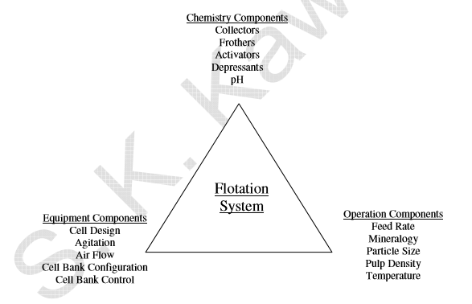 **Performance Calculations**

There is no one universal method for expressing the effectiveness of a separation, but there are several methods that are useful for examining froth flotation processes:

**(a) Ratio of Concentration,** the weight of the feed relative to the weight of the concentrate, The Ratio of Concentration is F/C, where F is the total weight of the feed and C is the total weight of the concentrate. One limitation with this calculation is that it uses the weights of the feed and concentrate. While this data is available in laboratory experiments, in the plant it is likely that the ore is not weighed and only assays will be available. However, it is possible to express the ratio of concentration in terms of ore assays. Starting with the mass balance equations, and the definition of the ratio of concentration:

F = C + T, Ff = Cc + Tt, Ratio of Concentration = F/C

where F, C, and T are the % weights of the feed, concentrate, and tailings, respectively; and f, c, and t are the assays of the feed, concentrate, and tailings. We now need to eliminate T from these equations so that we can solve for F/C:

Ff = Cc + Tt, and multiplying (F = C + T) by t gives us:

Ft = Ct + Tt, so subtracting this equation from the previous eliminates T and gives:

F(f - t) = C(c - t), and rearranging produces the equation for the ratio of concentration:

F/C = (c – t)/(f – t)

**(b) % Metal Recovery, or percentage of the metal** in the original feed that is recovered in the concentrate. This can be calculated using weights and assays, as (Cc)/(Ff)·100. Or, since C/F = (f – t)/(c – t), the % Metal Recovery can be calculated from assays alone using 100(c/f)(f – t)/(c – t).

**(c) % Metal Loss** is the opposite of the % Metal Recovery, and represents the material lost to the tailings. It can be calculated simply by subtracting the % Metal Recovery from 100%.

**(d) % Weight Recovery** is essentially the inverse of the ratio of concentration, and equals 100·C/F = 100·(f – t)/(c – t).

**(e) Enrichment Ratio** is calculated directly from assays as c/f, weights are not involved in the calculation

**Grade/Recovery Curves**

While each of these single calculated values are useful for comparing flotation performance for different conditions, it is most useful to consider both the grade and the recovery simultaneously, using a “Grade/Recovery Curve”. This is a graph of the recovery of the valuable metal achieved versus the product grade at that recovery, and is particularly useful for comparing separations where both the grade and the recovery are varying. A set of grade/recovery curves is shown in Figure 2. If 100% of the feed is recovered to the product, then the product will obviously have the same composition as the feed, and so the curve starts at the feed composition with 100% recovery. Similarly, if the purest mineral grain that contains the metal of interest is removed, this will be the maximum grade that can be produced by a physical separation, and so the 0% recovery end of the curve terminates at an assay less than or equal to the assay of the purest grains available in the ore. In the graphs shown in Figure 2, points that are higher and to the right show better performance than points that are lower and to the left.

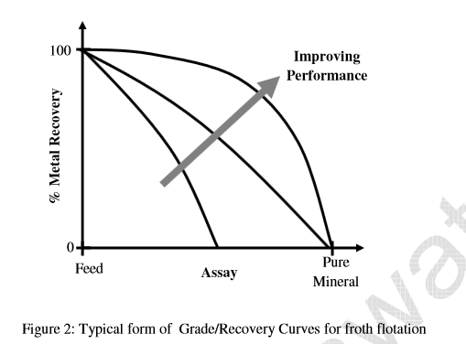

**Hydrophobicity/hydrophilicity**

The basis of froth flotation is the difference in wettabilities of different minerals. Particles range from those that are easily wettable by water (hydrophilic) to those that are water-repellent (hydrophobic). If a mixture of hydrophobic and hydrophilic particles are suspended in water, and air is bubbled through the suspension, then the hydrophobic particles will tend to attach to the air bubbles and float to the surface, as shown in Figure 3. The froth layer that forms on the surface will then be heavily loaded with they hydrophobic mineral, and can be removed as a separated product. The hydrophilic particles will have much less tendency to attach to air bubbles, and so it will remain in suspension and be flushed away (Whelan and Brown, 1956).

Particles can either be naturally hydrophobic, or the hydrophobicity can be induced by chemical treatments. Naturally hydrophobic materials include hydrocarbons, and non-polar solids such as elemental sulfur. Coal is a good example of a material that is typically naturally hydrophobic, because it is mostly composed of hydrocarbons. Chemical treatments to render a surface hydrophobic are essentially methods for selectively coating a particle surface with a monolayer of non-polar oil.

**Reagents**

1- collectors

2- frothers

3- modifiers

**Collectors** : main function of collector is it makes the selected minerals hydrophobic by forming a continuous film of heteropolar at molecular level. Due to this these minerals get adhere to air preferentially and start floating .

Collectors classification :

1- cationic- if the part which impart water repellancy to the mineral surface carries a negative charge

2- anionic - if the part which impart water repellancy to the mineral surface carries a positive charge Collectors are heteropolar that means one portion is polar and other is non polar.

Examples of collectors : Anionic collectors : potassium or sodium ethyl xanthate, dithio phosphate, fatty acids Cationic collectors: fatty amines acetates

**Frother :** main function is to form a stable and particular size of froth on which collector coated mineral get attached and floated up. These are heteropolar in nature having one of more water repellent and water loving polar group. The froth must be stable and strong enough to support the weight of the desired mineral attached to it and permits it separation from the pulp. Most important point is these froth must breakdown when they are removed from the flotation cell.

Examples : pine oil, aliphatic alcohol, cresylic acids

**Modifiers or regulator :**

They modifies the action of collector either by enhancing or by reducing its water repellent effect on the mineral surface .

They make collector action more selective towards certain mineral

1- activator – it help in reactivate or increase the susceptibility to flotation of some mineral that has been depressed ex- cuso4 is a standard activator for sphalerite

2- ph regulator: optimum result only in a particular ran ph value of the pulp .for this reason proper ph control of the pulp is of greater importance.

ex- ,soda ash, and h2so4

3- depressant : some times we want differential flotability for which it is desirable to prevent or supress the flotation of one mineral over another . Ex= cyanide,lime acts both as ph regulator and depressant

1. dispersant :sometimes the gangue may be of such nature that it flocculates to such an extent which may interfere with effieient flotation of the desired mineral . It is ess a dispersant . A dispersant or a dispersing agent or a plasticizer or a superplasticizer is either a non surface-active substance added to a suspension, usually a colloid, to improve the separation of particles an settling or clumping.Ex- starch and glue

**MAGNETIC SEPARATION**

Magnetic separations take advantage of the magnetic properties of minerals. All minerals will have one of three magnetic properties: ferromagnetic, paramagnetic, and diamagnetic. Ferromagnetic minerals (i.e., magnetite and pyrrhotite) are magnetic and are easily separated from other minerals, since they will be attracted to the poles of a magnet. Paramagnetic and diamagnetic minerals are not magnetic, but differ in how they interact with magnetic fields. Paramagnetic minerals are weakly attracted whereas diamagnetic minerals are weakly repelled along lines of magnetic forces. Thus, if a mixture of paramagnetic and diamagnetic minerals is passed through a magnetic field; the paramagnetic minerals will be pulled into the field and the diamagnetic minerals will be repelled or separated from the field. Furthermore, paramagnetic minerals have different degrees of paramagnetism that can also be used to effect separations.   
Magnetic fields of various intensities can be provided by permanent or electromagnets. Generally, magnetic separators are classified as low or high intensity and whether they work in wet or dry applications.

**Application in the industry:**

* They are used to protect vital process equipment downstream from damage while it produces a clean separated final product. At the same time it can effectively prevent long sharp metal shards from cutting, ripping or tearing conveyor belts, crushers, Grinding mills.
* The type and style of magnets used in industry will depend on its location within the process. Larger materials and deeper burden depth require larger magnetic to be operational.
* Magnetic separator that are suspended over the belt are typically designed to remove large ferrous material such as hand held tools, iron scrap, machinery tips. But can also remove nails, wire, nuts and bolts from the process.
* Depending on the type of mineral being mined, the size of tramp irons occurring will vary. Hence, magnetic separators require varying degrees of magnetic flux power so these are separated into electro magnets and permanent magnets. Depending upon the use we can select any of them.
* There are various application of magnetic separator in processing plant. Like in Coal processing plant we use Drum Separator to recover the Media.

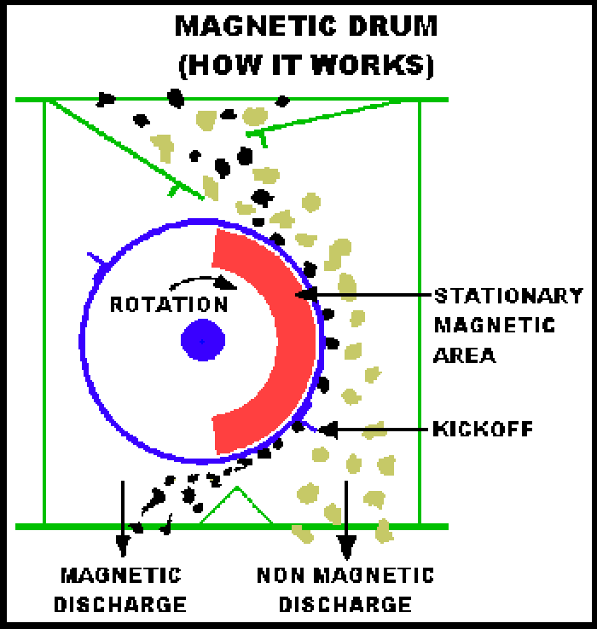

* Now a days other magnetic separation equipments are also being used in coal preparation industry. Like High Gradient Magnetic Separation.
* If we talk about the industries other than coal then there are wide application of Magnetic separator.

e.g in iron ore processing industry there is use of LIMS( Low intensity magnetic separator) also WHIMS( Wet High Intensity Magnetic Separator) and HGMS( High Gradient Magnetic Separator).

**Advantage by the use of Magnetic separator:**

* With the use of magnetic separators there are many areas where cost saving can be realised. These will include reduction of equipment maintenance and repair.
* Equipment will be able to run for much longer periods of time with minimal downtime and loss of production hours.
* Another obvious point would be the reduction of labor costs to maintain and repair equipment.
* Increment in the recovery of the minerals.

**SEPARATION OF MINERALS BY ELECTRIC SEPARATION**

Electrical separation utilizes the difference in Electrical conductivity between the various minerals in the ore feed. Since almost all minerals show some difference in conductivity it would appear to represent the universal concentrating method. In practice, however, the method has fairly limited application, and its greatest use is in separating some of the minerals found in heavy sands from beach or stream placers.

Steps for electrostatic separation process:

* The material will be initially sieved by screens to separate grains by size. Optionally, the grains of each given size can be passed through the appropriately sized mechanical grinders and sieved again for uniformity.
* The next step is to separate the mineral grains by a process called "electrostatic beneficiation", which means charging them with static electricity and separating them by passing them through an electric field, as pictured in the next figure.

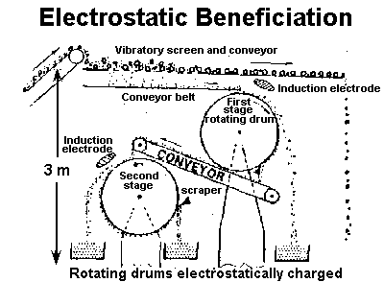

* After grains are sieved by size, they are placed through a beneficiator. After a few passes through beneficiators, we have separated different minerals fairly well. (There's no change in physical or chemical identity; there's only separation of minerals.)
* The grains are charged by any of the following methods: charging the screen that sieves them, or charging another surface which they slide over, or a diffuse electron beam as they fall. The charging method can depend upon which minerals we want to separate, since different minerals have different responses to different methods (and indeed to different temperatures, too).
* Electrostatic Separation works better in Vacuum because no air turbulence is there. Also Electric field can be 10 times stronger in Vacuum.
* Mostly Electrostatic separation method is used in processing of beach sand minerals.

**Flow Sheet of Beneficiation Chromite ore**

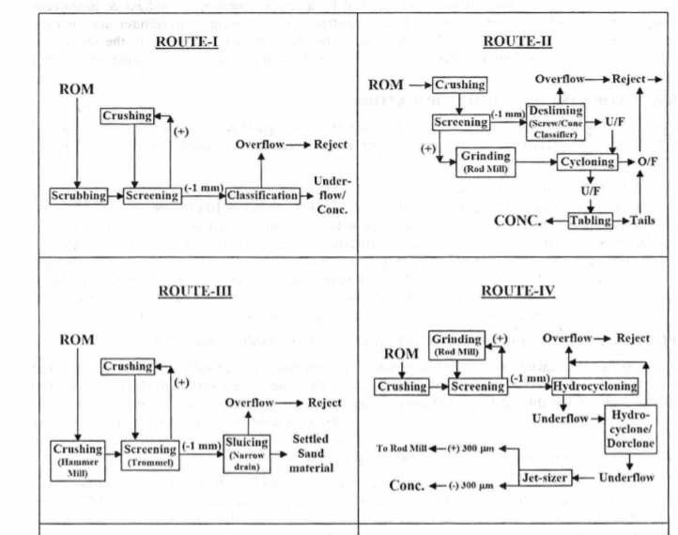

**Description**

The beneficiation of soft & friable chromite ore implied rejection of relatively find iron bearing impurities (limonite, goethite & ferruginous clay), which invariably occurs as fine cementing / binding material between the various chromite grains. In general, the crude beneficiation techniques in vogue are scrubbing, crushing, grinding, screening, classification (classifier / cyclone) & settling to produce the concentrate. The systematic methods used are scrubbing, crushing, grinding, screening, classification (classifier / cyclone) & gravity concentration (table / spiral) on classified feed to produce the concentrate. Some of the basic ore processing technologies (for friable ore) used in various Indian chrome ore processing plants (ref. figure-1) are as follows:

(i) Manual screening cum washing of ROM ore by spray of water in 2 mm size screen followed by vigorous manual churning of screen under-size in a settling tank. The coarse chromite concentrates were settled nearby whereas fine ferruginous materials were washed away as slimes. The oversize stacked and or sold to near by available market for beneficiation.

(ii) Crushing & screening to all -1 mm size and ■ Sluice in a narrow gentle sloping drain. Coarse concentrates settles in the slope nearby rejecting slimes of ferruginous material, which are carried away to a farther distance by action of water. • Treatment in hydro-cyclone followed by jet-sizer, i.e. hindered settling classifiers. ■ Classified (cyclone) to reject overflow slimes followed by treatment of cyclone underflow (sand) by Tabling.

(iii) Scrubbing cum screening of ROM ore to -1 mm size, followed by crushing and/or grinding of oversize to all -1 mm size and classification (spiral classifier/ cyclone). The underflow constitutes the final concentrate while the overflow is reject.

(iv) Crushing & grinding of ROM ore followed by de-sliming (cyclone), hydro-sizing of cyclone underflow into two size fractions followed by gravity concentration by spiral and/or table.

(v) Scrubbing of ROM ore followed by screening, crushing and grinding of oversize to all -1 mm size, followed by classification (spiral classifier / cyclone) to plus & minus 100 gm size, followed by gravity concentration employing spiral & table.

The first three process routes of beneficiation (practiced by minor player), have caused grave resource waste with a low rate of recovery, which is averaged between 40 to 50 % Cr203 as it concentrated chromite grains limited to 75 gm (200 mesh) size only.

In the subsequent process routes, chromite recovery is marginally better but then again it is limited to 50 gm size only with a loss mostly at size below 50 am & is inevitable due mainly to lack of properly developed process flow sheet & control in its process parameters. The maximum chromite recoveries in all these later process COB plants are ranging between 60 to 70% Cr203 only.

**IRON ORE BENEFICIATION**

Beneficiation Process:

1. Screening of raw ore through vibrating grizzely

2. +30mm size will be crushed by JAW CRUSHER

3. This material is again screened through D. D. Vibratory screen

4. -1mm will go to sump and +1mm will be fed to ball mill

5. Discharge of ball mill will go through H. SP. Screen

6. -1mm will go to sump and +1mm will be re-fed to ball mill.

7. From sump the material will be pumped to Hydro cyclone

8. Under flow from Hydro cyclone will be collected in sump and Pumped to cluster of

Cyclones

9. Under flow from cluster of cyclones will go to Primary spiral

10. From Primary Spiral concentrate will go to Secondary spiral and rejects will go to

tailing Pond

11. From secondary spiral – rejects will go to tailing pond, concentrate is finished product,

will go to stock yard and spiral middle will be re-fed to primary spiral.

12. Over flow of Hydro cyclone and cluster of cyclones will be collected in a sump and

Pumped to Desliming cyclone

13. Over flow will go to tailing pond and under flow will go to sump and pumped to

WHIMS.

14. The concentrate from WHIMS will go to stock yard as finished product and tail will go

to RCC bedded tailing pond.

15. Water from tailing pond will be taken in recovery tanks. There will be 3 recovery tanks

with RCC sloping bed, after settlement of solids water is removed for re-use and solids

will be scrapped out manually. The tanks will be used alternately while one is allowed

to dry other two will be in use. Scrapped solids will be sold for brick making.

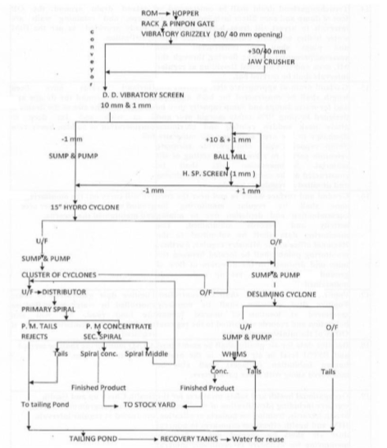

**BENEFICATION OF LEAD & ZINC ORES**

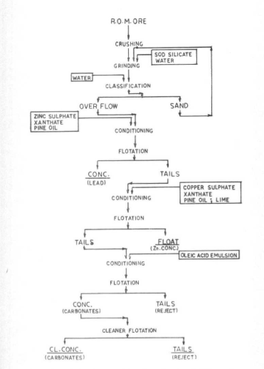

**ENVIRONMENTAL ISSUE DUE TO BENEFICIATION**

Metallic ores contain elevated levels of metals, they generate large quantities of waste. For example, the copper content of a good grade copper ore may be only one quarter of one percent. The gold content of a good grade gold ore may be only a few one-hundredths of a percent. Therefore, the next step in mining is grinding (or milling) the ore and separating the relatively small quantities of metal from the nonmetallic material of the ore in a process called ‘beneficiation.’ Milling is one of the most costly parts of beneficiation, and results in very fine particles that allow better extraction of the metal. However, milling also allows a more complete release of contaminants when these particles become tailings. Tailings are what remains following milling of the ore to fine particles and extraction of the valuable metal(s). Beneficiation includes physical and/or chemical separation techniques such as gravity concentration, magnetic separation, electrostatic separation, flotation, solvent extraction, electrowinning, leaching, precipitation, and amalgamation (often involving the use of mercury). Wastes from these processes include waste rock dumps, tailings, heap leach materials (for gold and silver operations), and dump leach materials (for copper leach operations). Leaching involving the use of cyanide is a kind of beneficiation process, usually used with gold, silver, and copper ores, that merits separate attention because of the serious environmental and public safety impacts. With leaching, finely ground ore is deposited in a large pile (called a ‘leach pile’) on top of an impermeable pad, and a solution containing cyanide is sprayed on top of the pile. The cyanide solution dissolves the desired metals and the ‘pregnant’ solution containing the metal is collected from the bottom of the pile using a system of pipes.

**TAILINGS DISPOSAL**

High-grade mineral ores consist almost entirely of non-metallic materials and often contain undesired toxic metals (such as cadmium, lead, and arsenic). The beneficiation process generates high-volume waste called ‘tailings,’ the residue of an ore that remains after it has been milled and the desired metals have been extracted (e.g., with cyanide (gold) or sulfuric acid (copper)). If a mining project involves the extraction of a few hundred million metric tons of mineral ore, then the mine project will generate a similar quantity of tailings. How a mining company disposes of this high-volume toxic waste material is one of the central questions that will determine whether a proposed mining project is environmentally acceptable. The key long-term goal of tailings disposal and management is to prevent the mobilization and release into the environment of toxic constituents of the tailings. An entire section of this Guidebook is devoted to a detailed comparison of tailings disposal options These options include: (1) the use of a wet tailings impoundment facility or ‘tailings pond’; (2) dewatering and disposal of dry tailings as backfill; and (3) sub-marine tailings disposal. The first option (a tailings pond) is by far the most commonly used option, but the second option (dry tailings disposal) is, in most circumstances, the environmentally-preferable option. The third option (sub-marine tailings disposal) is sometimes proposed with mine sites located near deep sea environments, or in rare instances in freshwater lakes. Sub-marine tailings disposal has a poor environmental record in the few instances where it has been practiced. Before the adoption of environmental laws and standards, many mining companies simply dumped tailings in the nearest convenient location, including nearby rivers and streams. Some of the worst environmental consequences of mining have been associated with the open dumping of tailings, a practice now nearly universally rejected.

**THICKENERS — TYPES, WORKING PRINCIPLE & APPLICATIONS**

Thickeners are important and widely used for mineral processing to make concentrate from ROM (raw ore) . Specifically, thickeners are used to increase the solid content of concentrate slurry (concentrate + process water) so that we can effectively deliver the concentrated slurry and re-use the process water.

Generally, thickeners are difficult to operate and design due to their large size and long-time residence.A thickener is a machine that de-waters slurry, separating the liquid from the solids. The solids' particle size range in thickeners is generally from 0.5 mm to a few microns. The finer the particle size, the slower settling and compaction rate of solids per square foot of surface area

**Working of a Thickener**

Let us understand in detail about how thickeners work. To start with, it works on the principle of Gravity sedimentation and the most common construction of a thickener would be of iron or steel.The continuous thickener consists of a cylindrical tank. Pulp is fed into the centre of the tank via a feed-well placed up to 1 m below the surface of the suspension. The clarified liquid overflows a trough, while the solids which settle at the bottom of the tank are withdrawn as a thickened pulp from an outlet at the centre. One or more rotating radial arms are there within the tank, from each of which are suspended a series of blades, shaped so as to rake the settled solids towards the central outlet.With modern thickeners, there is a functionality of these arms rising automatically if the torque exceeds a certain value, thus preventing any damage which can result due to overloading. The blades also help in concentration of the settled particles by simple setting which enable a thicker underflow. In this way, solids move downwards, and then inwards towards the thickened underflow outlet and the liquid moves upwards and radially outwards.

**Types of thickeners**

The thickeners can be classified into two types depending on location of rake driving mechanism. They are known as either Centrally driven or Peripherally driven.

Further, under centrally driven type there are two types depending on method of supporting the drive mechanism and the raking arms.

1. a) Column type: A kind of thickener where a central steel or concrete column takes vertically the reaction to the weight of the mechanism and horizontally the torque load.
2. b) Bridge type: Here, a structure spans across the tank and is subjected vertically to the weight of the mechanism plus any solids that accumulate within the arms truss and horizontally to the twin forces imposed by the density of the raked underflow.

Generally, and for larger diameters the former type is used and for tanks up to 25–30 meter diameter the later type is preferred.

**What are high-capacity thickeners and how they work?**

In the 1980’s, machines known as “high capacity” or “high rate” thickeners were introduced by various manufacturers. These machines are characterized by a reduction in unit area requirement for conventional installations.Here, the feed enters through a hollow drive shaft where flocculent (used to help thickening) is added and is rapidly dispersed by staged mechanical mixing. Further, this staged mixing action helps to improve and enhance thickening. This feed is then added into a blanket of slurry where the feed solids are further flocculated by contacting previously flocculated material. Since there is a direct contact between rising fluid and settling solids, which is common to most thickeners, it is averted with slurry blanket injection. There are radially mounted inclined plates which are partially submerged in the slurry blanket; the settling solids in the slurry blanket slide downwards along the inclined plates, producing faster and more effective thickening than vertical descent. Level sensor are used to automate the height of the slurry blanket.

**Factors determining efficiency of Thickener**

Several types of thickeners have been developed and classified according to the arrangement of feed and discharge in the various compartments.For effective thickener control, key considerations are bed mass inventory, underflow density and flow, bed level, overflow clarity and flocculent dosing. All these parameters and measurements of these are not easy and one must factor in accuracy and reliability to select and install the proper equipment. Some of thickening equipment from well-known and respected brand names such as [Eimco](https://www.savonaequipment.com/en/en/equipment/thickeners-e41613?s=la), [FLSmidth](https://www.savonaequipment.com/en/en/equipment/thickeners-e41613?s=sm), [Dorr-Oliver](https://www.savonaequipment.com/en/en/equipment/thickeners-e41613?s=na), [Phoenix](https://www.savonaequipment.com/en/en/equipment/thickeners-e41613?s=ma), [Lamella](https://www.savonaequipment.com/en/en/equipment/thickeners-e41613?s=vc) and [Westech](https://www.savonaequipment.com/en/en/equipment/thickeners-e41613?s=) are popularly used.

